**CHAPTER I**

**INTRODUCTION**

**Background of the Study**

The different platforms of technology nowadays support browsers and there is increasing accessibility to the internet. Web applications have become popular and they play a crucial role in the branding process. With their help, there will be no installation on the hard drive required, so it does not cause space limitations. Moreover, web apps will help to solve most of the device compatibility issues, and whatever device they are using as long as it has an internet connection and a browser, they were able to use the web application.

Web applications such as the Cemetery Management System aims to help both parochial/admin staff to record and track deceased person records. Saint Peter & Paul Cemetery is a Roman Catholic Cemetery is managed and administered by the Parochial of Saint Peter & Paul. It was located on Rizal Avenue Street, Ticad, Bantayan Island Cebu. The cemetery was founded on the year 1919 by Don Francisco Y. Maderazo the grandson of Kapitan Tawi who discovered the Bantayan Island. **(Rubio, 2022)**

The cemetery has an estimated population of three hundred fifty-seven thousand (357,000) together with the bone chamber as of 2022**. (Desquitado,2022)**

In the local setting, at Suba, Bantayan, Cebu where the Parochial that manages the Saints Peter & Paul Roman Catholic Cemetery was located. During the transactions with the clients, it was difficult to manage cemetery records and locate the grave locations of their loved ones. Moreover, no cemetery management system is intended for the needs of Saint Peter and Paul Roman Catholic Cemetery that enables the admin to register the deceased, a system that has the potential to report the data of the deceased, and the convenience for the Parochial admins to monitor the billing statement virtually, with the systematic way of managing and tracking locations of deceased, parochial admins will be able to manage and locate all the deceased records faster without hassle.

Cemetery Management System plays an important role in terms of faster transactions with the clients during the registration of the deceased and the convenience for the Parochial admin to check, record, and monitor the deaths yearly data. There are existing Cemetery Management Systems developed and are widely used nowadays, but this one is tailored and customized for the need of Saint Peter and Paul Roman Catholic Cemetery. One of the features of this system is the capability to automatically moved the data records of the deceased person to “Dako nga cross”. Parochial admin to manage payment records, yearly payments, and Billing statements of the deceased data. It contains a dashboard with data analytics about the population of the deceased that belong to the different categories of data. It also has the capability to send emails to the contact person of the deceased to notify them about their unsettled or unpaid monthly payment for niches.

**Objectives of the Study**

**General Objectives**

This study aims to develop Saint Peter & Paul Roman Catholic Cemetery Management System.

**Specifically, it aims to:**

1. Design a system that filters data according to the needs of the admin at Saint Peter & Paul Cemetery.
2. Name of the deceased
3. Date of burial
4. Date of expiration/Remaining Years
5. Yearly payments
6. Provide options for the admin to manage the deceased’s data:
   1. Grave number
   2. Grave section
   3. Date of transfer
7. Print the data of the system:
   1. Billing statement
   2. Receipt
8. Display on the dashboard with data analytics the following:

a. Total death

b. No. of deceased or population that belong to different categories of niche.

c. No. of a population of deceased rumbarunon.

d. No. of the population to those who paid every month.

5. Payment email notification.

6. Determine the quality of the developed system based on the **ISO/IEC 25010:2011**Systems, Software Quality Requirements, and Evaluation (SQuaRE) Quality Model.

7. Determine the usability of the developed system based on the following criteria: Usefulness; Satisfaction; Ease of Use and Learning.

**Scopes and Limitations**

Saint Peter & Paul Roman Catholic Cemetery Management System is composed of the following sections of the system:

1. **Registration.** Saint Peter & Paul Roman Catholic Cemetery Management System allows the parochial admin to input the names of the deceased people, the date of burial, and its location.
2. **Reservation**. This part of the system shows the grave space in a cemetery as long as it remains open to new burials.
3. **Status.** This part of the system shows the status of the deceased if it is already close to the date of expiration of burial the service for final disposition.
4. **Expiration.** This part of the system shows the remaining free years of the deceased for the yearly payment before rumbar or final disposition of bones. This web app feature will help them organize records of yearly payments.
5. **Location.** This part of the system shows the exact section and numbers of the grave.
6. **Payment Records.** This part of the system shows the first notice of payment and the date of expiration.
7. **Billing statement.** This part of the system shows the summary of paid bills.
8. **Niches.** This part of the system shows the different categories of niches.
9. **Yearly payment.** This part of the system shows the yearly payment of the deceased person of their availed niches.
10. **Dashboard.** This part of the system shows the data analytics of the different files about the deceased.
11. **Email Notification.** This part of the system shows and uses the email that will notify the contact person about their unpaid monthly rent of the niches.

The Cemetery Management System is intended only for Saint Peter & Paul Roman Catholic Cemetery. Moreover, the said management system is also having its own limitations. The Management System can only hold the customer contact information and also the records of the deceased person. The functionalities of this system are being tailored and customized according to the needs of the aforementioned Roman Catholic Cemetery.

**Significance of the Study**

The development of Saint Peter & Paul Roman Catholic Cemetery will be of great help to the following:

* **Parochial Officer/Admin.** The developed system will help the admin in monitoring their burial services. This system allows them to track the records of the deceased virtually and allows them to have the final summary and reports of the burial.
* **Family of the deceased.** This system helps the family of the deceased with faster transactions to minimize prolonged waiting time.
* **Saint Peter & Paul Roman Catholic Cemetery.** Through this system, the cemetery will have a smoother operation than before in terms of its service, tracking records, and managing data.
* **Future Researchers.** The study may help future researchers with their inquiries regarding the web app known as Saint Peter & Paul Roman Catholic Cemetery Management System. This study could be a big help, especially to their query regarding how Cemetery Management System works.

**Definition of Terms**

These are the following terms, which are operationally defined for a better understanding of the study of Saint Peter & Paul Roman Catholic Cemetery Management System:

**Billing statement**

**Conceptually.** A billing statement is a monthly report that credit card companies’ issue to credit card holders showing their recent transactions, monthly minimum payment due, and other vital information. Billing statements are issued monthly at the end of each billing cycle.

**Operationally.** In this study, billing statement refers to the reports of records of billing transactions of clients yearly payment of niches.

**Bone Chamber**

**Conceptually.** A vault or building where corpses or bones are deposited.

**Operationally.** In this study, the bone chamber refers to the cells where the bones of the corpses are deposited.

**Cemetery Management System**

**Conceptually.** Cemetery Management System is a system that can monitor and track the deceased person. It allows the admin to record and manage the burial services. It enables the parochial officers/ admin of cemeteries a simple, web-based system for accessing the data summary of the cemetery and the registry of the deceased.

**Operationally.** In this study, the Cemetery Management System is defined as a web-based system that is intended for the use of Saint Peter & Paul Roman Catholic Cemetery in managing the deceased monthly record and generating printed receipts and billing statement.

**Dako nga Cross**

**Conceptually.** This term is defined as the symbol of the crucifixion of Jesus Christ and symbolized the belief of Christian religions across the world.

**Operationally.** In this study*, “Dako nga Cross”* refers to the destination of the bones that were being rumbar. All bones from a different person were disposed of together in this place.

**Dashboard**

**Conceptually.** This term is defined as a data dashboard a tool many businesses use to track, analyze, and display data usually to gain insight into the overall well-being of an organization, department, or specific process.

**Operationally.** In this study, the dashboard is the data analytics that contains the information of populations of the deceased belonging to different categories of data.

**Deceased**

**Conceptually.** This term is defined as a dead person.

**Operationally.** In this study, the deceased is the body that was being buried in the Sts. Peter & Paul Roman Catholic Cemetery.

**Email Notification.**

**Conceptually.** This term is defined as an email you send out to notify subscribers about changes and updates to your product, or service.

**Operationally.** In this study, Email notification refers to the email you send to the contact person of the deceased to notify them about their unpaid monthly payment of niches.

**ISO/IEC 25010:2011 Systems and Software Quality Requirements and Evaluation (SQuaRE) Quality Model**

**Conceptually**. The quality model is the cornerstone of a product quality evaluation system. The quality model determines which quality characteristics will be taken into account when evaluating the properties of asoftware product.

**Operationally.** in this study, this is being used as an evaluation instrument for the survey results regarding how wholesome the developed system is.

**New tri- level**

**Conceptually**. This term is defined as a new tri-level having three levels or floors.

**Operationally.** In this study, new tri-level refers to a newly-made niche, never used by someone’s body remains.

**Old tri-level**

**Conceptually**. This term is defined as one side, there is a half-flight of stairs leading up or down to the next level.

**Operationally**. In this study, old tri-level refers to a niche that was already occupied by someone’s dead body and was disposed of then can be replaced by another body.

**Old tri-level with bones**

**Conceptually**. This term is defined as one side, there is a half-flight of stairs leading up or down to the next level.

**Operationally**. In this study, old tri-level with bones refers to a niche that was already occupied by someone’s dead body and was disposed of that can be replaced by two remains but the other one is already bones.

**Parochial Staff/Admin**

**Conceptually.** This term is defined as a person who is responsible for the upkeep, reliable operation, and configuration of computer systems.

**Operationally.** In this study, it refers to the person who was assigned of keeping the records and has access to the management system. The admin can add, transfer and delete records of the deceased in the system or just view the list of the deceased.

**Patong Solo Nicho/Niche**

**Conceptually.** This term defines as a coating putting on top, layer, layering, coating, interest on a loan, superimposed.

**Operationally.** In this study, “*Patong solo nicho*” refers to a niche that can be layered into a solo niche.

**Payment**

**Conceptually**. This term is defined asthe action or process of paying someone or something or being paid off**.**

**Operationally.** In this study, payment refers to the yearly bill of the relatives of the deceased for the availed package of burial.

**Registration**

**Conceptually.** This term is defined as an act of making an official record of names and other information.

**Operationally.** In this study, registration refers to the registering of information about the deceased for burial records.

**Reports**

**Conceptually.** a report is a document that presents the information in an organized format. It is a concise summary distilled from a larger set of data, intended for a specific group of people or audience.

**Operationally.** in this study, a report is a summary of the Saint Peter & Paul Roman Catholic Cemetery Management System. It also shows information about the deceased, the receipt, and, yearly payment, and the billing statement.

**Reservations**

**Conceptually.** This term is defined as an area of land that is kept separate for a particular group of people to live in.

**Operationally.** In this study, reservations refer to the vacant niches that can be reserved for another new occupant’s corpse.

**Rumbar**

**Conceptually.** This term is defined as white overproof rum produced in Jamaica and sold worldwide by Worthy Park Estate.

**Operationally.** In this study, “*Rumbar”* refers to the final disposition of bones and moved to the *Dako nga Cross.*

**Saint Peter $ Paul Roman Catholic**

**Conceptually.** A Catholic cemetery located in the municipality of Bantayan Island.

**Operationally.** In this study, Saint Peter & Paul Roman Catholic Cemetery is the chosen establishment for the proposed system.

**Section**

**Conceptually.** This term is defined as a distinct part or subdivision of anything, such as an object, class, or country.

**Operationally.** In this study, it is defined as the number and section of the grave or niche and where it was located.

**Solo Nicho/Niche**

**Conceptually.** This term is defined as a place or position that’s particularly appropriate for someone or something, especially due to being very specific and different from others.

**Operationally.** In this study, “*Solo nicho”* refers to the solo niche that occupies a big area without any niche besides or layered on it.

**Transfer**

**Conceptually.** This term defines as a change to another place, route, or means of transportation during a journey.

**Operationally.** In this study, transfer refers to the change of locations of the deceased from a niche to another category of niche or moved to the *bone chamber.*

**Conceptual Framework**

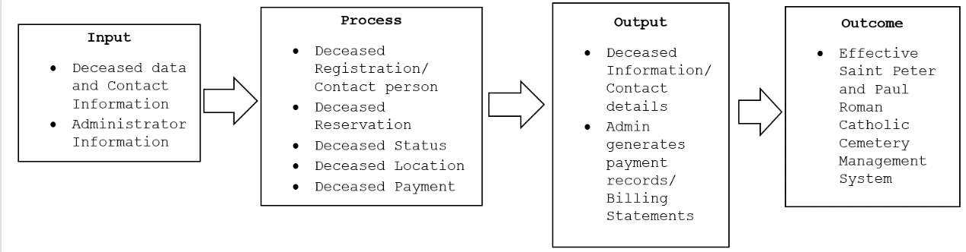The Conceptual Framework of the Cemetery Management System illustrates the inputs, processes, outputs, and outcomes of the system. It illustrates the flow from the inputs to its process until the desirable outcomes.

**Figure 1. Conceptual Framework of the web application Cemetery Management System.**

Figure 1 shows the necessary data to be inputted into the system to produce desirable and purposeful outputs. The inputs consist of Client/User information and Administrator information. The web application will accept all the aforementioned inputs and process them into meaningful information such as the summary of the Death data and the Saints Peter and Paul Roman Catholic Cemetery Management System. The web application, Cemetery Management System will provide outcomes that allow the tracking of death data will be easy as well as to generate a summary upon request. The outcomes of this study will be beneficial to all the visitors of the cemetery who visits their loved ones’ graves, especially to the parochial admin/staff to easily manage death records to perform a better service and faster transaction with the clients.

**CHAPTER II**

**RELATED LITERATURE AND PRIOR ARTS SEARCH**

**Related Literature**

**The need for STS. Peter & Paul Roman Catholic Cemetery Management System**

The Cemetery Management System is managing cemeteries with the use of technology. This system enables users to keep track of all data regarding lots, residents, sales, and a cemetery map. The cemetery maps, plot owner and burial data, and work orders are all digitally preserved as a result. The reduction of effort and time required is the main goal of this method. Additionally, to switch from paper and pen to a mobile and desktop device. The Cemetery Management System is very helpful for both cemetery employees and visitors as it aids in managing cemetery records and locating gravesites more swiftly and effectively. It provides many advantages for cemetery.(Gamaz et.al., 2018). These results suggest that Cemetery Management System is the best tool in managing cemeteries as it addresses all the problems that cemeteries are experiencing.

The study of R. Komalasari (2020, highlights the structure that is anticipated to be able to enhance social welfare. Cemetery administration is still done by entering burial plot information, together with information on the bodies and heirs, in the application ledger or books. The cemetery guards are unable to recall the number of graves and locations on the public cemetery site. Due to this, it’s challenging for managers to search for cemetery records. Creating a Cemetery information system is essential because it can be used by the cemetery service to offer burial data and cemetery information and the system can produce cemetery information. These study suggest that developing Cemetery Information System is important because it can be used by the administrator in managing their cemeteries to provide information of the deceased.

Through the study of (S. Abdullah et.al., 2022), emphasized that the most current and practical information source today is the internet. Apart from Geographic information systems (GIS) also serve as the basis for the system for developing web-based cemeteries systems. The general public gain from the creation of the Cemetery Web and the GIS database system is adequate, convenient, and trustworthy for everyone, especially for the heirs when they went to the cemetery to visit the family grave. This developed system can provide deceased information to everyone, and it can facilitate processing information more quickly and efficiently in burial records. A database will contain the deceased's details, including name, death date, and cemetery plot number QR codes can be used to search for information on the deceased as well. These finding suggest that cemetery web and database system is convenient for everyone as the system provides and facilitate information more quickly.

The study correlates with study of (S. Sarı et.al., 2017), highlights the importance of CIS to cemeteries with these system citizens will be able to access the information of their relatives who died in the cemetery via the internet, and they will be able to see the locations and photographs of the graves on their screens and get the maps showing the locations of the graves. In addition, the citizens who want to visit the graves of their relatives will be able to easily find the graves. This system enables the development of new burial spaces, which allows assembling, researching, and evaluating all data (location, burial and cemetery records, geographical and non-geographic data, death records, etc.). These results suggest that Cemetery Information System is vital in cemetery management as it allows managing and evaluating records.

In addition, the study of (Wellim & Fauzi, 2017) highlights the usage of appropriate technology in order to have a positive impact on the course of funeral services in terms of workmanship funeral activities. The new cemetery overlaps the extensions of the users' permission tomb until the report generation in situations where the burial services are still utilizing a system of writing in the book and ledger. In order to address the issues of frequent human mistakes and the length of time needed for report preparation, it is crucial that a cemetery services information system is suitable for the demands of cemeteries. Every funeral can print a receipt that automatically processes the data saved in the computer. The database has made it possible to store large amounts of data, which allows cemetery workers to work more effectively. These finding suggest that a cemetery information System is suitable to address the issue of frequent human made error and to reduce the length of time in processing reports.

The study by (Sien & Ramachamdrian, 2018) highlights that the e-Cemetery portal increases the efficiency of the existing Cemetery Management Systems. Traditionally the memorial service providers manually process data, Keep data on hard copies rather than electronically. Finding and retrieving information from cemeteries is a difficult task detail regarding the dead. Finding a particular cemetery or retrieving a specific body is a laborious task for consumers the ancestor’s records because cemetery administration system now in place is less user-friendly. In order to meet the needs of the next millennium, this report suggests the e-Cemetery system, which attempts to emphasize difficulties with cemetery management. These finding suggest that e Cemetery System improves the effectiveness of the existing cemetery systems it emphasizes problems exist in cemeteries.

The study conducted by (Chibuye & Phiri, 2022) highlights the factors that affect record keeping in cemetery Management using the Technology Acceptance Model （TAM）. Presently record keeping is managed manually and the cemetery markings on the grave have disappeared on old graves and those without tombstones or any landmarks. This made the relatives of the deceased fail to locate the graves for maintenance. The study sought to establish methods to ensure effective Automated cemetery management using the Technological Adaptation Model （TAM）to establish perceptions of electronic Management for cemeteries. These result suggest that using Technological Adaptation Model is crucial method in securing effective Automated Cemetery Management systems to initiate perceptions.

The study conducted by (Demir & Yogeswaran, 2018) highlights the importance of finding the location of graves is difficult and challenging because different regions have different practices and policies in managing burials. It is not easy for relatives to identify the graves of their loved ones in a cemetery having thousands of graves. The study addressed the problem through the use of geotagging. The developed method allows the user to click the pictures of the grave and add the needed information about the deceased. These finding suggest that the developed method addressed the problem of locating and identifying the graves of deceased.

The study by (L. Schmidt, et.al., 2020) explores the use of geospatial technologies to support local cemetery management in the face of resource constraints. Hard-copy data from a handwritten ledger was manually entered into an Excel table. The full plots and all of the generation categories showed clustered patterns. These findings will help cemetery management in the area plan for future growth as well as historians and other people who are interested in the history and culture of the area in the future. The suggested techniques can make gathering cemetery data at the local level much easier. These result suggest that using technologies in managing local cemetery contributes the future growth of management and other people who are fond of history. It gathers cemetery data faster than using manual technique.

Therefore, the study conducted by (M. Sultana, et.al., 2021) highlights that the cemetery management system is the key to accomplishing these goals to solve all the problem faced by the cemeteries right now such as the lack of cemetery keep up as urbanization arises. Additionally, manual approaches are used to maintain cemeteries and complete the documentation using paper, which takes a lot of time and requires maintenance also simple to lose. Consequently, the digital graveyard management system is essential for accessing and storing data information about cemetery management while guaranteeing user satisfaction, efficacy, and efficiency.These findings suggest that Cemetery Management System solves the problems of cemetery management in managing all the data of the cemeteries.

**Data Analysis**

In an article published by Karin Kelley entitled “What is Data Analysis: Methods, Process and Types Explained”, in 2022 defined as the process of cleaning, changing, and processing raw data, and extracting actionable, relevant information that helps businesses make informed decisions. The procedure helps reduce the risks inherent in decision-making providing useful insights and statistics, often presented in charts, images, tables and graphs.

The study of Muhammad Ibrahim entitled “The art of Data Analysis” in 2015 defined data analysis as a process of performing certain calculations and evaluations in order to extract relevant information from the collected data. In addition, the word analysis according to him refers to a closely-related operation those are performing with the purpose of summarizing the collected data and organizing in such a manner yielding answer to the questions. In simple words, it means studying the data to determine inherent facts.

In an article by William M.K (2022) on Descriptive, statistics are used to describe the basic features of the data in a study. He added that descriptive statistics provide simple summaries about the simple graphics analysis and can form the basis of virtually every quantitative analysis of data.

There is limited research specifically focused on data analysis of cemetery management systems. However, some studies have been conducted on cemetery management systems in general, which may include analysis data.

“A Study on Cemetery Management System using QR Code” by M. Krishnaveni and K. Gopalakrishnan (2020)- This study proposes a cemetery management system using QR codes to identify graves and manage cemetery records. The systems collects data on cemetery plots, burials, and visitors, which can be analyzed to improve cemetery operations.

“Cemetery Information System: GIS-based Cemetery Management System” by S.S Rajpoot, et al.(2019)- This study presents a GIS-based cemetery information system that manages cemetery records and generates burial reports. The system uses spatial data analysis to optimize cemetery layout and improve cemetery operations.

“Data Mining Approach for Cemetery Management System” by A.M.A Elsayed, et al. (2018)- This study proposes a data mining approach for cemetery management that analyzes cemetery records to identify trends and patterns. The approach can be used to optimize cemetery operations and improve decision-making.

“Development of a Cemetery Management System using RFID Technology” by H.M.F.C. Bandara, et al. (2017)- This study proposes a cemetery management system using RFID technology to identify grave and manage cemetery records. The system collects data on cemetery plots, burials,and visitors which can be analyzed to improve cemetery operations.

Overall, these studies suggest that cemetery management systems can benefit from data analysis to improve cemetery operations and decision-making. However, more research is needed specifically focused on data analysis of cemetery management systems.

**The Importance of Email Notification in Cemetery Management System**

There is limited research on specific topic of email notifications in cemetery management systems. However, several studies have highlighted the importance of effective communication and information sharing in the management of cemeteries, which suggest that email notifications could play a valuable role in this context.

For example, a study by the National Funeral Directors Association found that families expect clear and timely communication from cemetery managers about burial arrangements, maintenance schedules, and other cemetery-related information. Inadequate communication can lead to dissatisfaction and even legal disputes. Email notifications can be useful tool for providing this communication in a timely and efficient manner.

Another study by the University of Guelph in Ontario, Canada, identified communication with stakeholders, including families, funeral directors, and cemetery staff, was found to be essentials for maintaining high standards of cemetery management. Email notifications could be used to facilitate this communication and keep stakeholders informed about cemetery operations and developments.

Overall, while there is limited research specifically on the importance of email notifications in cemetery management systems, there is clear evidence of the importance of effective communication and information sharing in this context. Email notifications could be an important tool for achieving these goals and improving the overall management of cemeteries.

**Prior Arts**

Here are the nearest prior arts of this Cemetery Management System:

**Everark**

This Cemetery Management Software is a comprehensive funeral solution software that tracks, sells, and manages burial plots and services with inventory management, sales tracking, customer organization, invoicing, maintenance control, and record keeping. Everark is an all-in-one funeral solution and cemetery management software. (Everark, 2022)

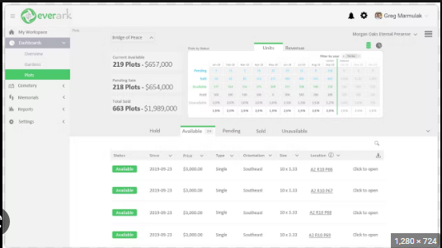

**Source**:<https://www.capterra.com/p/239533/EverArk/>

**Grave Discover**

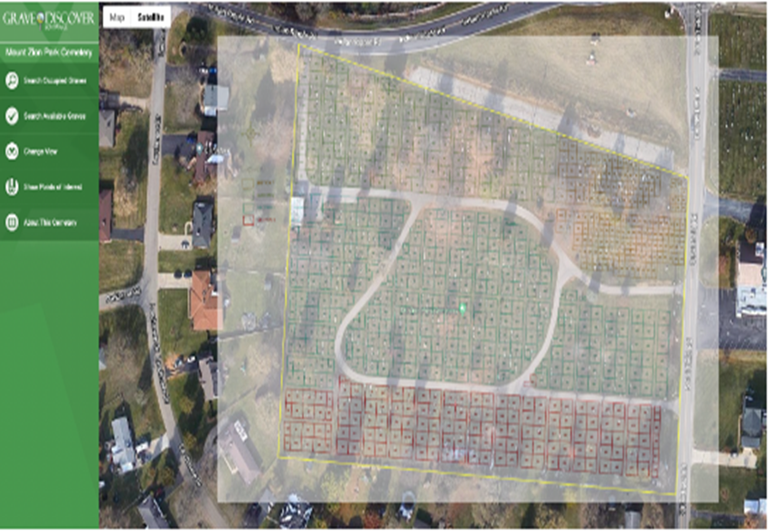 Grave Discover cemetery software allows cemeteries to both keep records organized and store and back up their data within reliable cloud servers. It can digitize all the cemetery records into an easy-to-use and organized inventory. This cemetery software has great database management features to allow the administrator to manage burials, occupants, plot owners, deeds, grave types, grave locations, headstone images, and more. The management screens have been through vigorous usability tests to ensure that the customers can quickly and easily update their cemetery and grave information. (Grave Discover, 2022)

**Source**:<https://www.beavercreekohio.gov/752/Grave-Discover>

**CemSites**

CemSites catholic cemetery cloud software is a management program created to meet your Diocese’s specific cemetery needs. When you are wanting information fast, CemSites cemetery cloud software can provide you with an answer immediately. Automate processes and workflows. Auto-generate documents to reduce handwritten errors, see work being done and completed in record time, and stay up to date with rules and regulations. It keeps your records safe – When your data is stored and backed up in the cloud, it is safe from whatever disaster may come at your business.(CemSites, 2022)

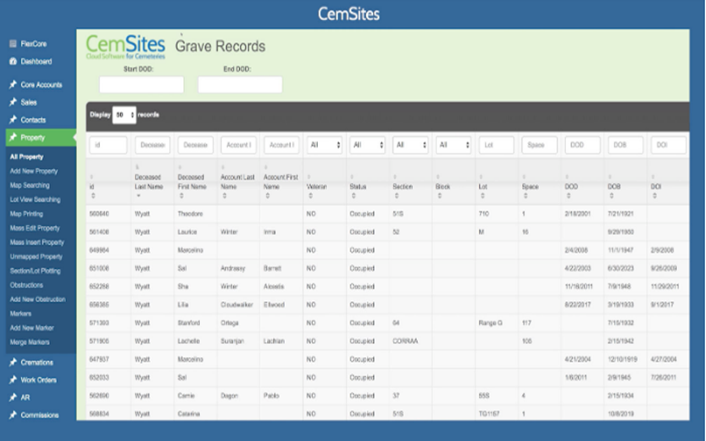**Source**:<https://cemsites.com/cemeteries-by-type/catholic-cemeteries/>

**PlotBox**

PlotBox is a records management system for cemeteries and crematoria that intuitively brings deceased electronic records together into a single, quickly searchable database. With one click you can see who owns and who’s buried in the plot, along with other related records, including images of headstones, paper records, and linked locations. (PlotBox, 2022)

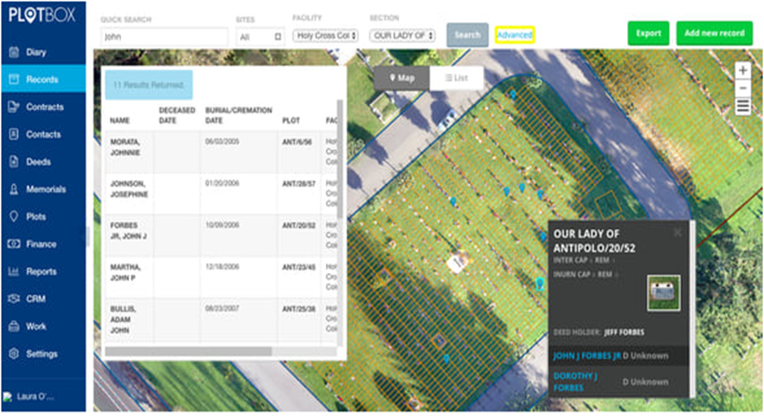**Source**:<https://www.plotbox.io/records-management>

**NewCom’s CMS**

NewCom’s Cemetery Software and Management system is based on a GIS mapping interface that supports all areas of cemetery management. The cemetery software solution includes plot sales with automatic deed generation, burial permits, updated interment information, and comprehensive reports. NewCom has created the missing link for cemeteries that want the power and sophistication of today's newest technology. NewCom's CMS is based on GIS (Geographic Information Systems) technology, which provides a comprehensive map-based program to assist with cemetery property and record management. (Newcom.CMS, 2013)

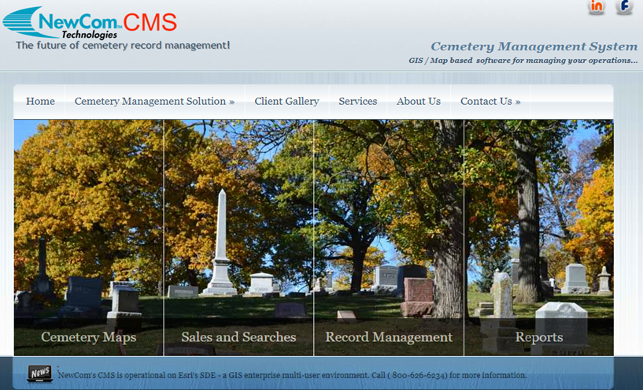 **Source**:<http://cemetery.newcomtech.com/>

**Cemetery Find**

“Cemetery Find is an easy-to-use search database that includes scanned paper records linked to each burial and lot record. Create new burial records and lot sales, plus add veteran status. Cemetery mapping is available with real-time updates and burial location navigation! Cemetery Find converts existing data from any source; Excel, Access, or any other database.

View scanned paper records and computer files in one seamless, easy-to-use records management system. Easily add new lot sales and burials. Search, locate, and navigate to a burial location without visiting the cemetery office**.** (Cemetery Find, 2020)

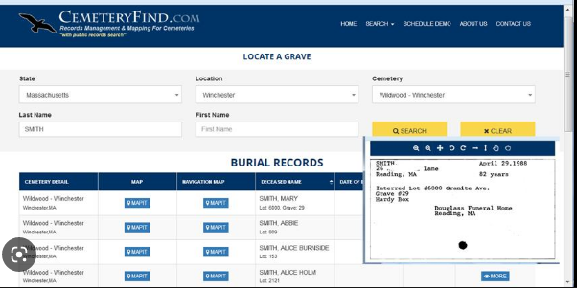**Source:**<https://www.bosscan.com/cemfind.html>

**GeoCem**

GeoCem is a Cemetery Management system that makes record-keeping easy. Replace your old deed books and paper maps with an easily accessible and interactive online system that allows users to add plot owners and burial records in just a few clicks. Add plot owners, occupants, and burial records in just a few clicks. Helps the administrator manage document templates, pricing, events, cemetery workers, plots dimensions and type as well as stakeholders. Quickly search for records and plot ownership with ease generate PDF documents including invoices, Grant of exclusive rights. Efficient lease management including expired lease alerts and expiry letter generation**.** (Geo Cemetery, 2020)

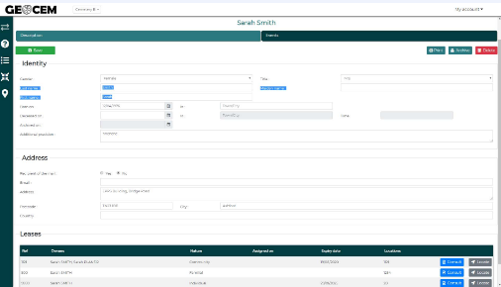 **Source**:<https://cemeterysoftware.co.uk/>

**Cemify**

Cemify is a cemetery software that is designed to be easy to use from the start, with optional features that grow with your cemetery. The software features, keep up-to-date records on plot ownership, burials & sales information. Report on sales, burials, plots, work orders, and more. This serves as a printable walking map for special projects and allows families to browse and find available spaces in the cemetery**.** (Cemify, 2021)

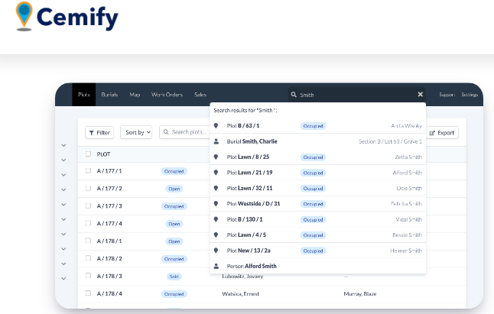**Source:**<https://www.cemify.com/features>

**Scribe**

Manage all types of cemeteries online from wherever you are working. Easy to use, cloud-based software including cemetery records, satellite mapping, grave inspections, burial register, and more. Digital backup of records and unlimited support are included across all plans. Records Database cemetery records detail all your burial, exclusive and memorial records. Easily manage and automatically back up records and documents**.** (Scribe, 2020)

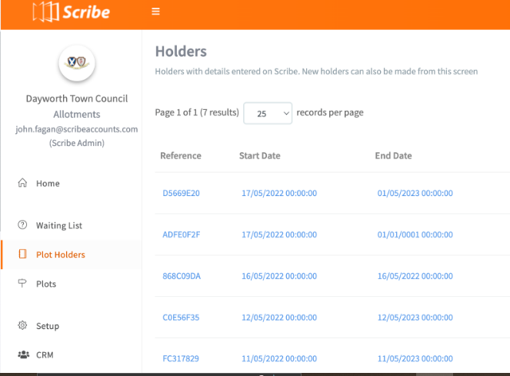

**Source:**<https://www.scribeaccounts.com/cemetery>

**Axiom**

This easy-to-use, mobile-friendly tool makes it simple for families to locate loved ones in cemeteries, with self-service abilities such as viewing deceased and service information, accessing walk-to-grave directions, seeing a visual map overview of the cemetery, and accessing a gallery of images. (Axiom, 2022)

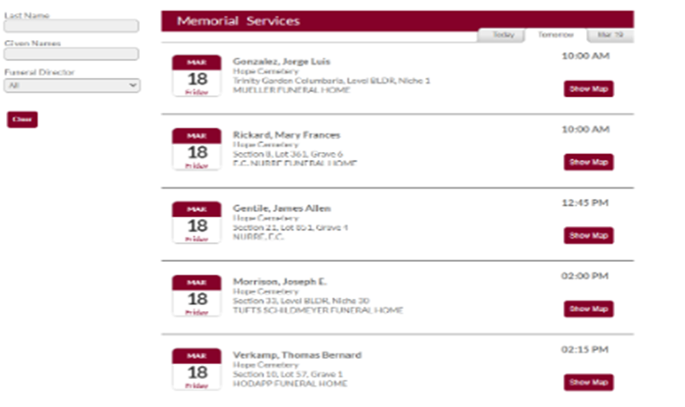

**Source:**<https://axiom-cms.com/solutions/experience/>

**Inettutor**

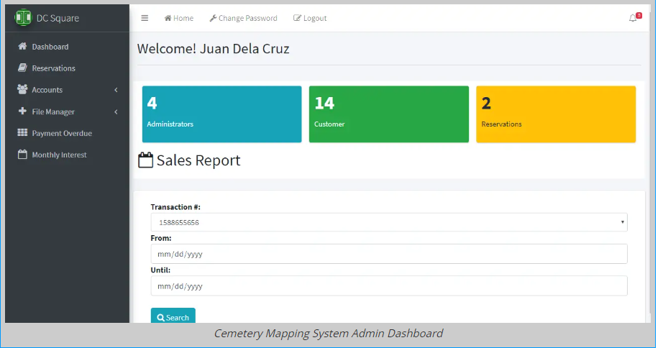The system can be accessed by the cemetery management and the customers/clients. The customer needs to register its personal information (full name, address, contact, email address). Once the account has been activated, the customer can now login, view the vacant block/lot and apply for reservation of nitio. The transaction will be validated by the management and notify the customer via email or SMS for the payment process. Necessary documents required must be complied to complete the transaction. With the simplified process, the management can monitor the payment overdue and reports of sales can be generated in a matter of time. (Inettutor,2023)

**Source**:https://www.inettutor.com/source-code/online-reservation-of-cemetery-with-map-navigation

By reviewing all the Prior arts, there are features that correlates with the developed Cemetery Management System. First, it can auto-generate documents to reduce human made errors, see work accomplished efficiently, completed in record time, and stay up to date. Allows the admin to create, update, delete, edit and save records of deceased. It helps and enables the administrator to find records easily and locate grave locations to provide information to the client faster. The administrator manages records, prices of lots, lease payment, events, plots dimensions and type as well as stakeholders. Uses great database management features to allow the administrator to manage burials, occupants, plot owners, deeds, billing records, grave types, grave locations such as the grave number and section. Provide payment invoices for the client.

All of these mentioned features above of prior arts can also be found in the developed Cemetery Management System. These features can help the Cemetery management to provide a better service to their clients and become an effective cemetery of the community.

**Synthesis**

Through the review of cited literature, there have been many reasons why there is a need for Cemetery Management System to fulfill the establishment or organizational goals, eliminate problems, and have hassle-free in terms of tracking death records and locating graves. Some other studies and systems even enhanced the capability of Cemetery Management Systems like the integration of QR codes, file exports, GIS (Geographic Information System) technology, and many others. Moreover, the studies underscore the need for a database that will serve as the storage of the deceased records and the grave's location. The development of most of the systems is Web applications and Web-based systems. Therefore, these types of systems are crucial to solve the portability and compatibility issues when it comes to Cemetery Management Systems.

# **CHAPTER III**

**METHODOLOGY**

This research study of STS. Peter & Paul Roman Catholic Cemetery Management will use the Developmental Research methodology. It is the systematic study of designing, developing, and evaluating instructional programs, processes, and products that must meet criteria of internal consistency and effectiveness **(Seels & Richey, 1994)**.

**Software Life Cycle Model**

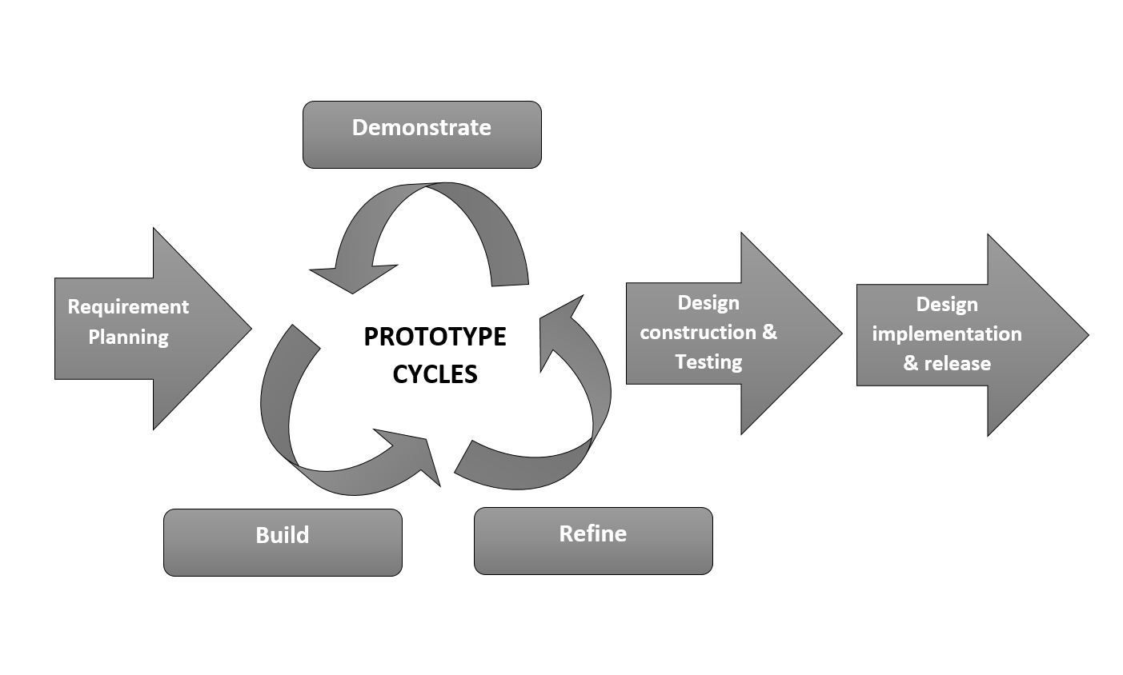In this study, the researcher used the system development methodology which is the Rapid Application Development (RAD) model in developing the Web Application, the Cemetery Management System.

**Figure 2. Rapid Application Development model**

This study employs the rapid application development methodology, which has proven useful for cutting

development time and completing software and web applications quickly. Rapid Application Development is also advantageous when there are several inputs during the development process.

This research uses the Rapid Application Development approach which is been useful for software and web application development that is needed to get done quickly and to cut development time. Moreover, Rapid Application Development is useful when having a lot of inputs during the developmental process.

**RAD Software Phases**

The following are the phases of the Rapid Application Development in developing the Cemetery Management System Web application:

**Stage 1. Requirement Planning**

In this stage, the existing problems like the need for the Cemetery Management System and the scopes of the system that are to be created were discussed with the administrator. The scope and goals through the development process were determined which gives highlights the importance of a Cemetery Management System. Moreover, the scope and requirements of the web application were carefully discussed and the researcher was making clear targets.

**Step 2. Prototype Cycles (Demonstration, Refine, Build)**

After the requirement planning with the administrator, the researcher proceeds to the prototype cycle.

The second phase involves the development of the model of the system (prototyping). In addition, the researcher demonstrates the system to the client. For instance, when the problems and lacking the system are noticed by the user, the developer will refine the web application. Upon this phase, the client and the developer will coordinate with one another. The process will literate until the system’s scopes and functionality being required are achieved.

**Step 3. Design Construction and Testing**

This phase involves the testing of the functionality of the Saint Peter & Paul Roman Catholic Cemetery Management System while ensuring that almost all of the scopes and functionalities of the web application are already working. During this phase, there will be the possibility that additional functionality and or elements are being added to the web application as per the client's requests but depending on the developer's capability to add the functionality. Feedback from the client will allow this phase for the web application's code to be rewritten and retested.

To test the Saints Peter and Paul Roman Catholic Cemetery Management System, the researcher will ask for consent from one of the clients and Parochial admin in Saints Peter & Paul Roman Catholic Cemetery to use the system. They will be exploring the functionalities and modules of the web application.

The users and the experts tested the Saints Peter & Paul Roman Catholic Cemetery Management System.

**Step 4. Design Implementation and Release**

This phase is the final step of the development of the web application before it goes to launch. This phase involves training the users on how to use the system. The web app during this phase is now usable and performing its purpose but it still needs maintenance and monitoring.

**Schedule Feasibility**

**Gantt Chart**

The timetable of the project was shown in Figure 3. It shows the gradual development from scratch into a fully developed system which is the Saints Peter & Paul Roman Catholic Cemetery Management System. Moreover, it displays the list of tasks with their corresponding length of time to finish.

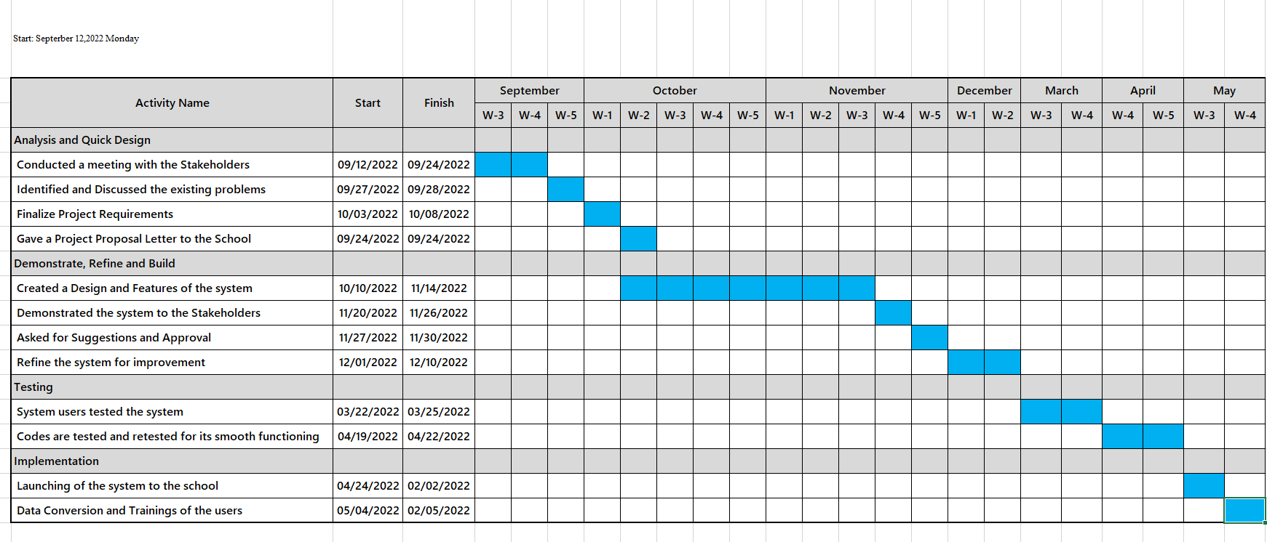

**Figure 3. Gantt Chart**

A Gantt chart is a project management tool that visualizes and depicts a project's schedule. It gives task start and finishes dates. It also aids in keeping up with expectations. The chart involves two sections: the left side outlines a list of tasks and the right side that shows the timeline with corresponding schedule bars to visualize work **(Meardon, 2021)**.

**Requirements Modeling**

**Context Flow Diagram**

Context Flow Diagram is also known as a Level 0 Data Flow Diagram (DFD). A Data Flow Diagram is the highest form and it points out the flow of information between the system and the external components **(Edrawsoft, 2021)**.

Context Flow Diagram depicts the system as a single high-level process, as well as the system's relationships with other external entities like other systems, organizational groups, external data storage, and so on **(Adams, 2021)**.

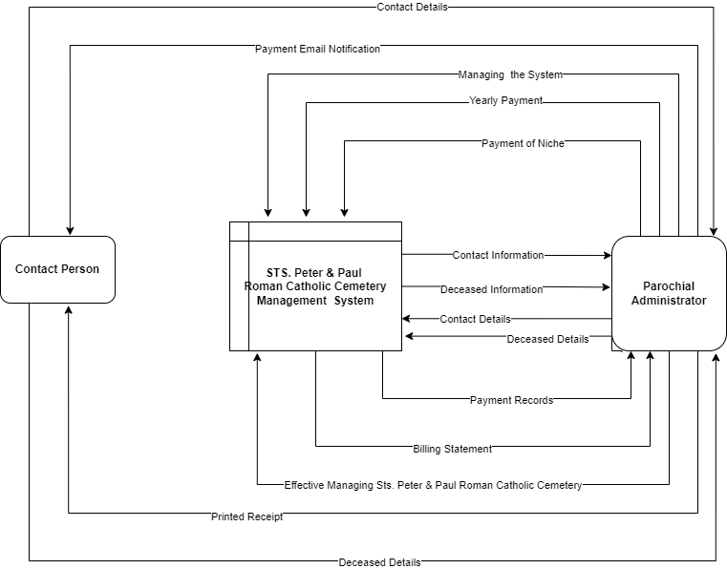

**Figure 4. Context Flow Diagram**

**Data Flow Diagram**

A Data Flow Diagram (DFD) is derived from a freehand “paper and pencil” technique that uses bubbles as process symbols and arced arrows as data flows. A DFD is a diagram that shows where the data come from, where they go, where they stored, and what happens to them on the way**. (Yourdon and de Marco).**

The figure below shows and illustrates the process of the Cemetery Management System. Through this illustration, the users will have an idea about the functionalities, how it works, and the processes of the web application.

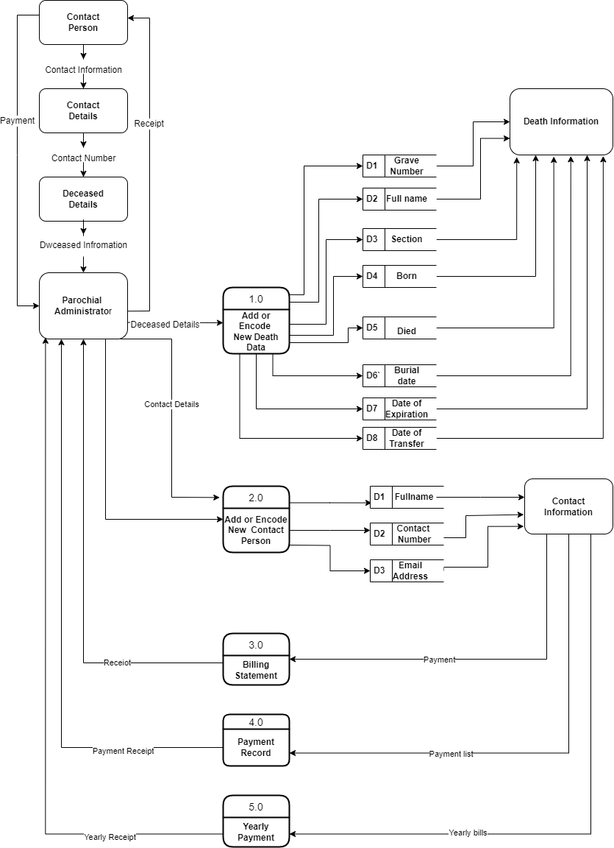

**Figure 5. Data Flow Diagram**

The data Flow Diagram was categorized into Logical DFDs and Physical DFDs. Logical DFDs represent the logical information flows that will identify the general processes, systems, and activities in relatively abstract terms. On the other hand, physical DFDs depict physical information flow details, including information systems, databases, and applications **(Nolle, 2021)**.

**Entity – Relationship Diagram**

An Entity-Relationship (ER) Diagram is also known as ERDs or ER Model. It is a type of flowchart that illustrates how entities relate to each other within a system. It depicts the relationships between entities, their interconnectedness, and their properties using a predetermined set of symbols such as diamonds, ovals, rectangles, and connecting lines (**Lucidchart, 2021)**.

Entity Relationship Diagram (ERD) uses data modeling techniques that can help define a business process. It is the tool that serves as the foundation for a relational database **(Biscobing, 2021)**.

The figure below illustrates the Entity-Relationship Diagram of the Cemetery Management System and it shows how the entities are related to each other in one system.

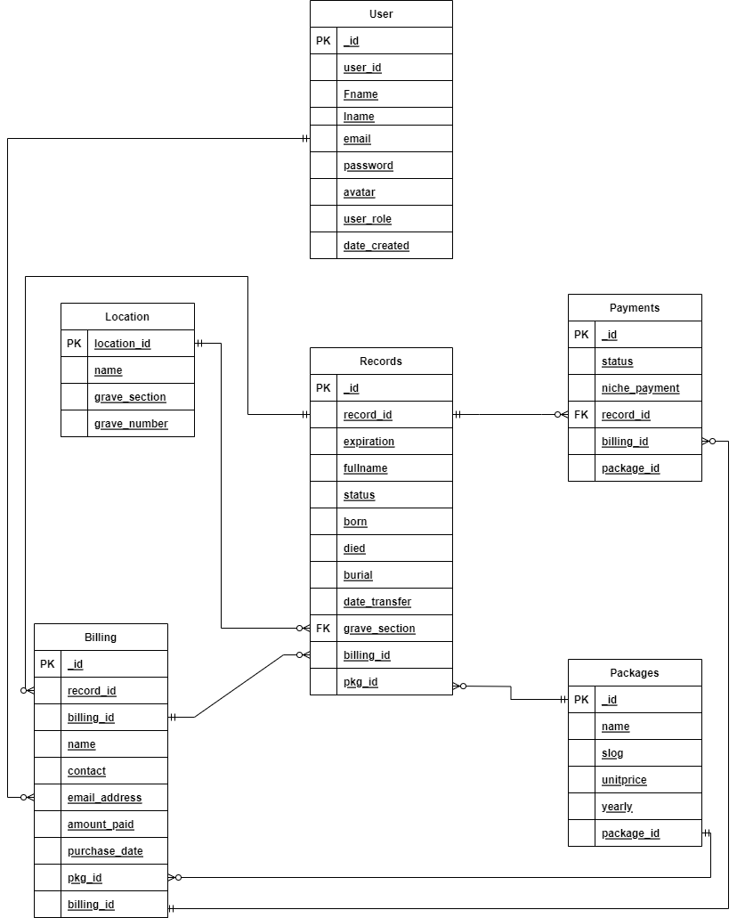

**Figure 6. Entity-Relationship Diagram**

Entity relationship Diagram represent entities as boxes, and relationships as lines between the boxes. Different shapes at the ends of these lines represent the relative cardinality of the relationship. These symbols are used in pairs to represent the four types of cardinality that an entity may have in a relationship. **(Crow’s foot)**

**Application Architecture**

The Application Architecture of the Cemetery Management System illustrates the overall architecture of the system. It shows what devices and technologies are being used in the implementation of the web application.

Application Architecture will guide the application design and will provide principles that will influence design decisions **(Gartner, 2021)**.

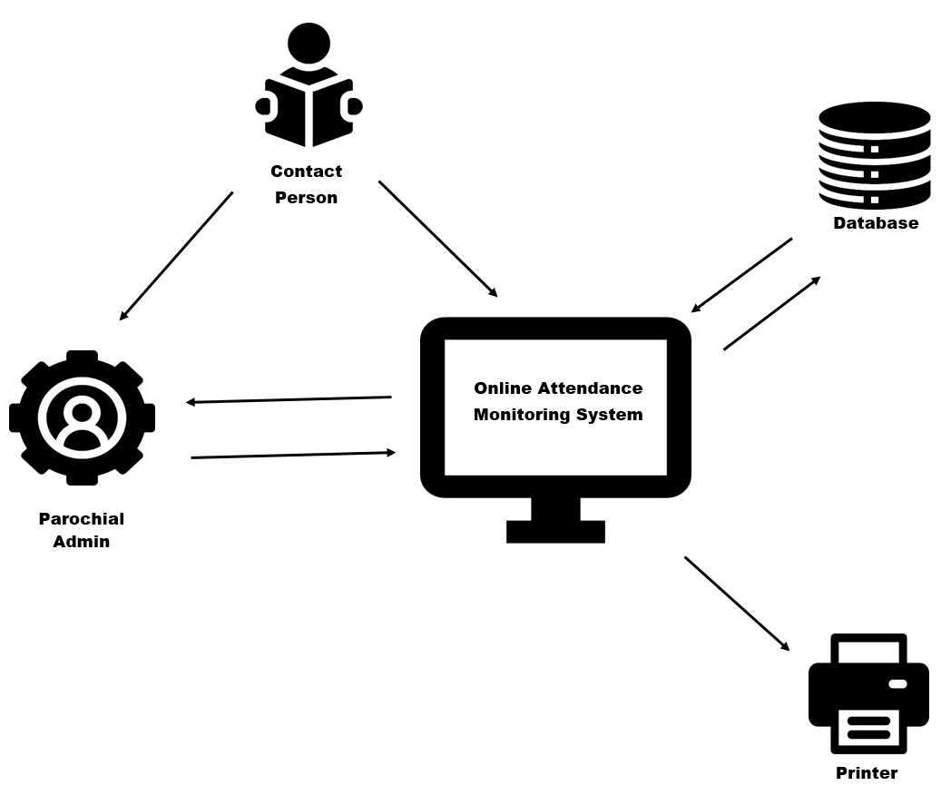

**Figure 7. Application Architecture**

Application Architecture illustrates the patterns and techniques being used to design and build an application. It provides a roadmap and recommended practices to follow when developing an app, resulting in a well-structured app **(Redhat, 2020)**.

**Use-Case Diagram**

Use-Case Diagrams are used to describe the information about the system's users and their interactions with it. It represents scenarios, goals, and the scope of the system with a collection of specialized symbols and connectors **(Lucidchart, 2021)**.

Use case diagrams are essential for visualizing the functional requirements of a system. It helps to identify any internal and external factors that influence the system **(SmartDraw, 2021)**.

The use case diagram is a behavioral diagram in the Unified Modelling Language (UML)which is used to depict object-oriented programming systems, and processes as well as business processes**(Unified Modelling Language).**

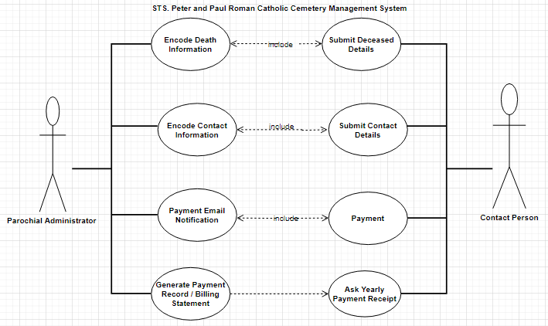

**Figure 8. Use-Case Diagram**

Figure 8 illustrates the Use Case Diagram of the Cemetery Management System which identifies two (2) actors: The Parochial Administrator and the potential client or customer. The mentioned agents are the essential part of the system and they are either direct or indirect users of the Web application.

**SYSTEM FLOWCHART**

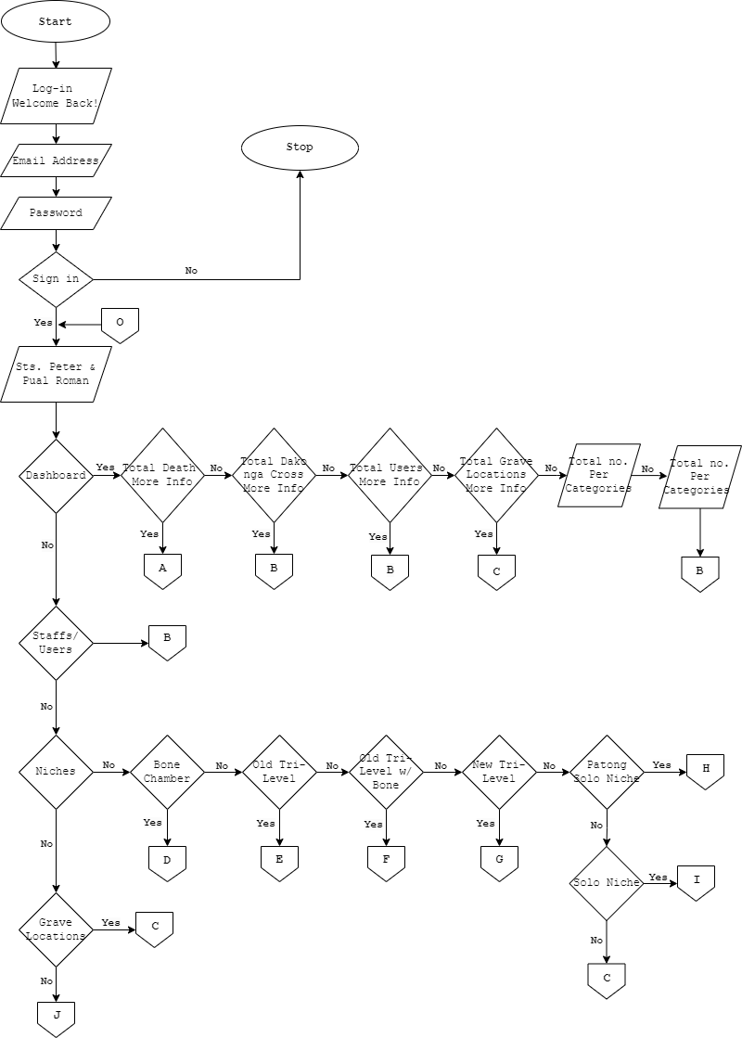

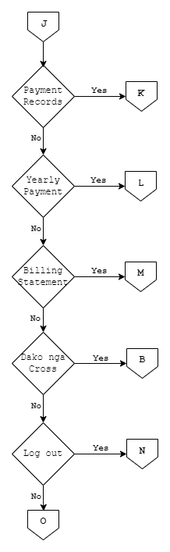

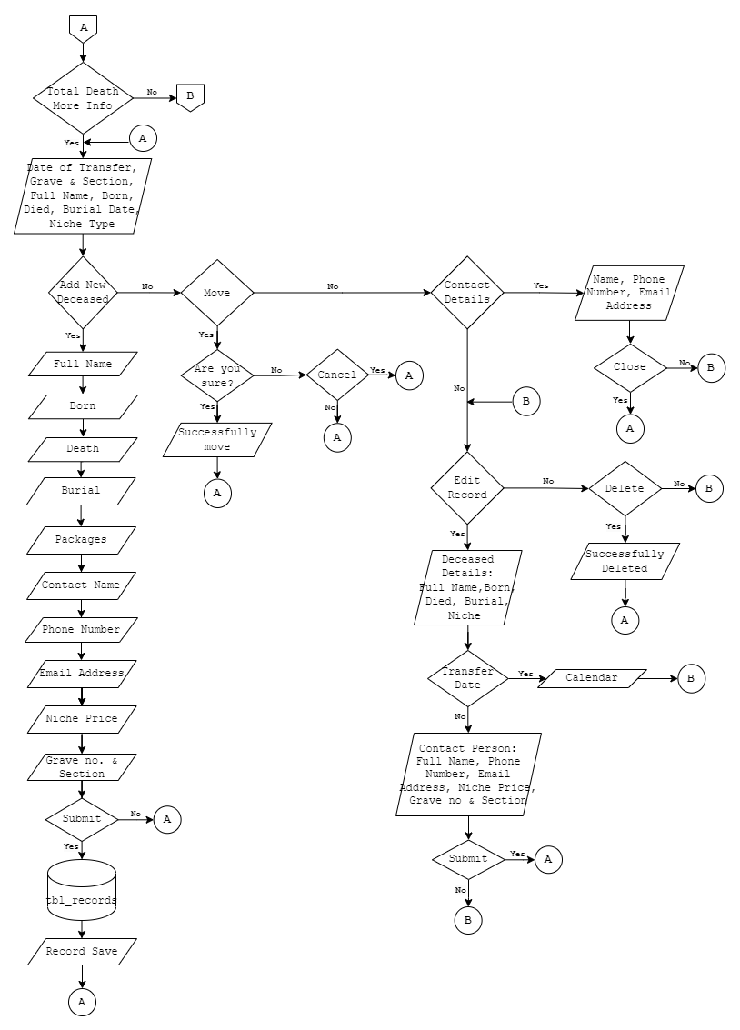

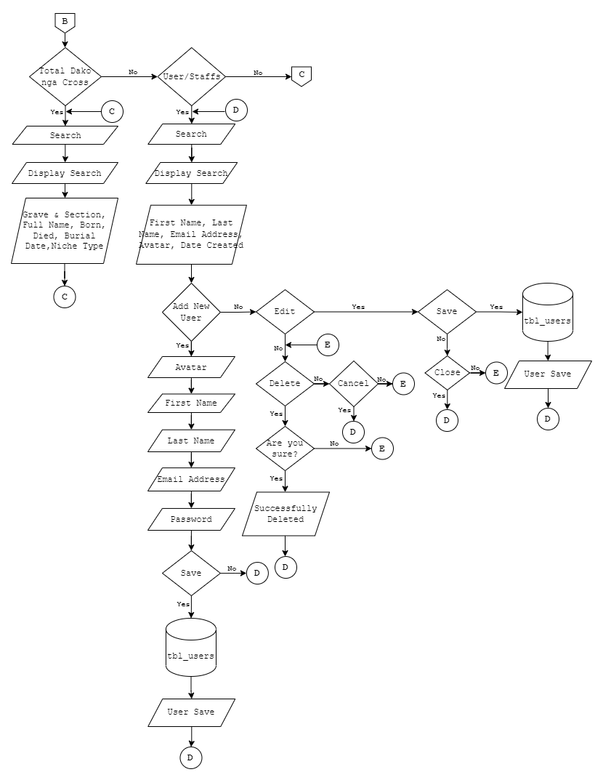

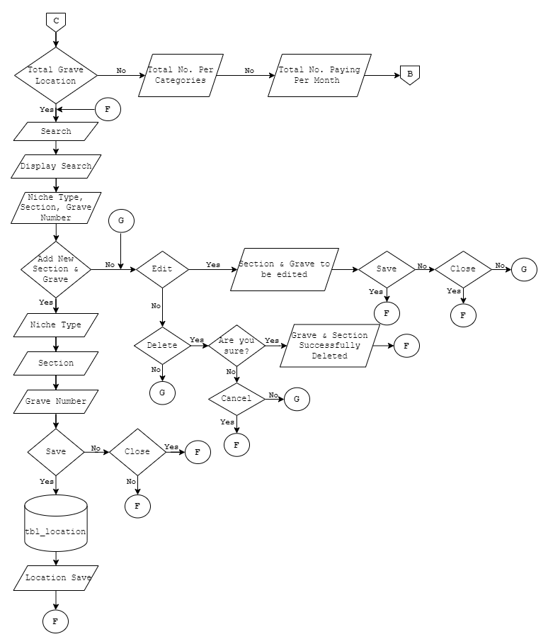

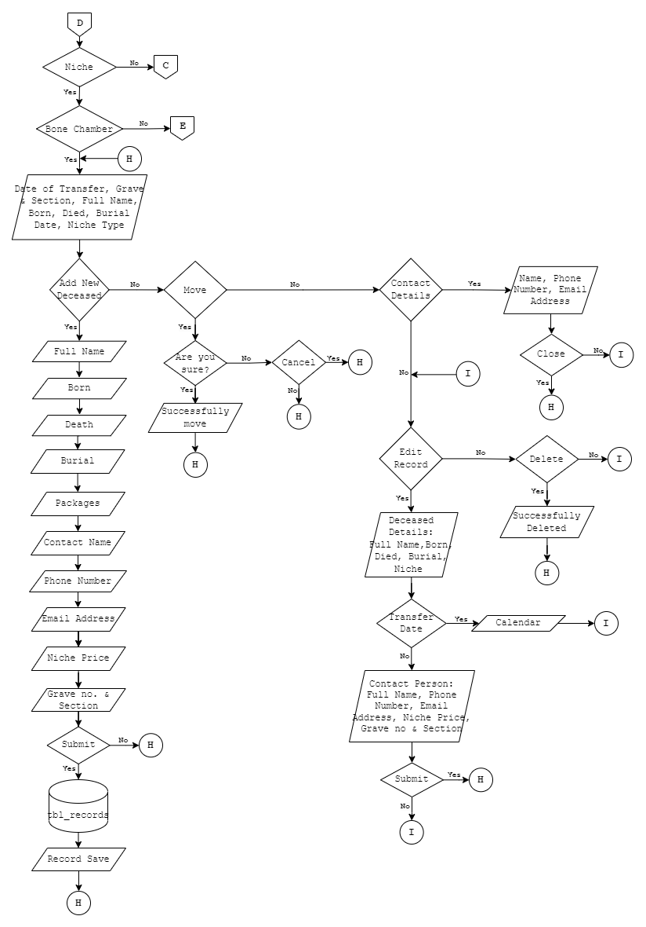

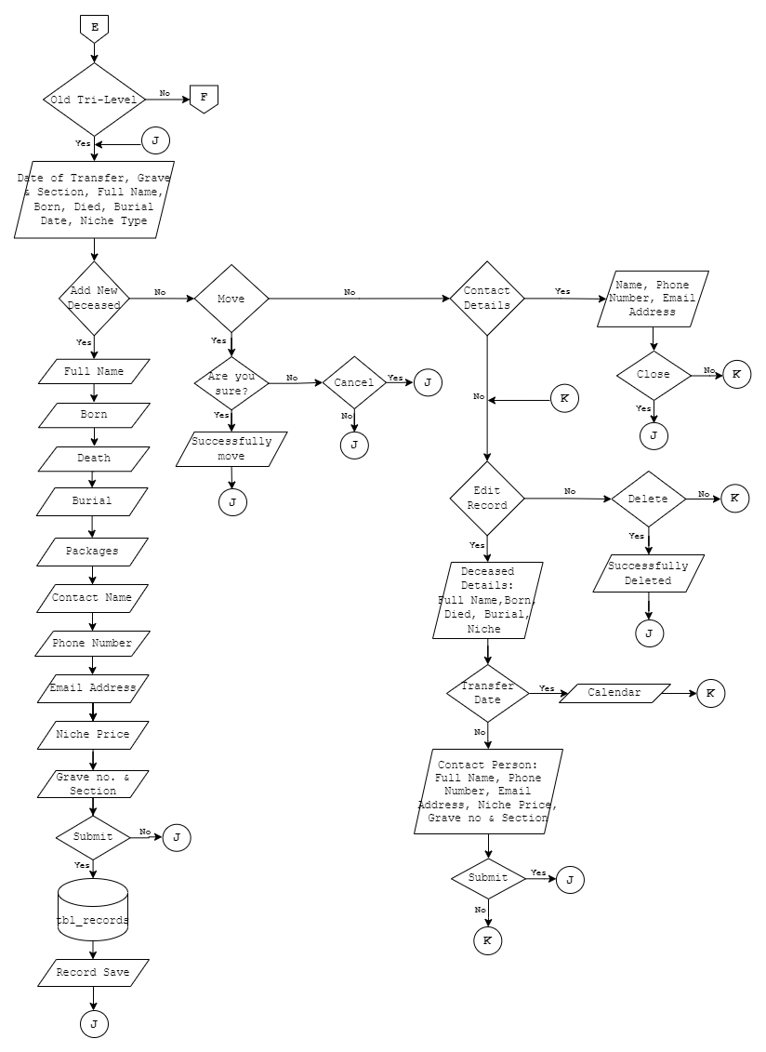

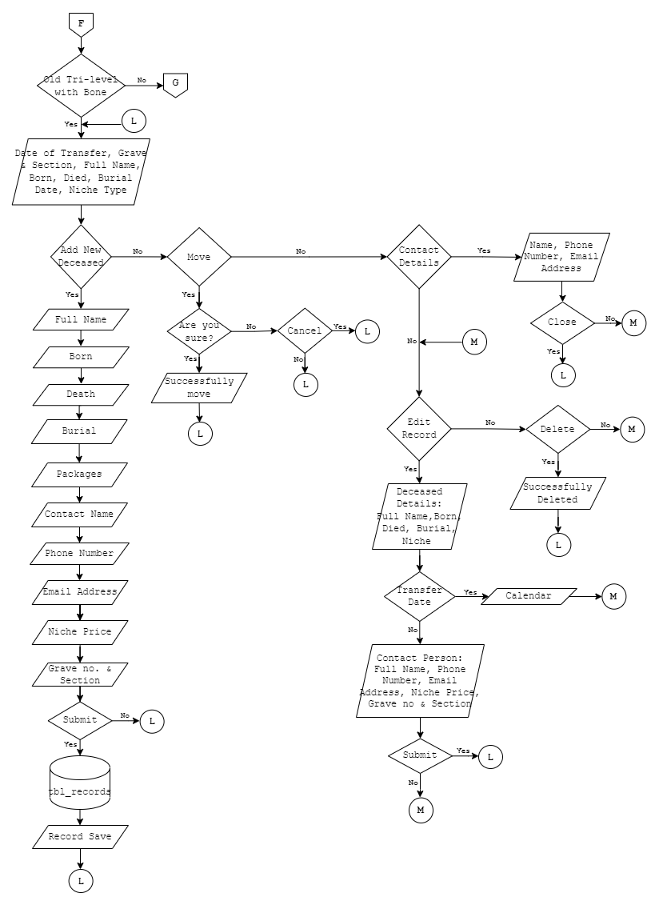

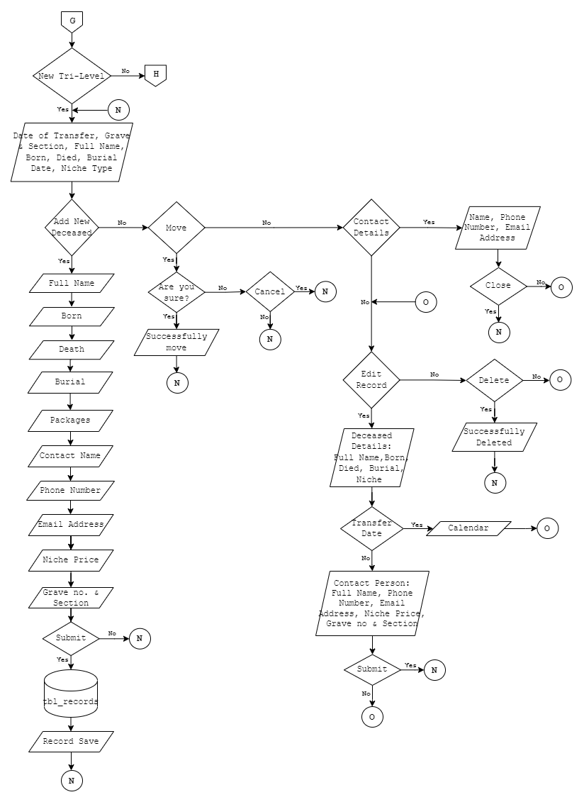

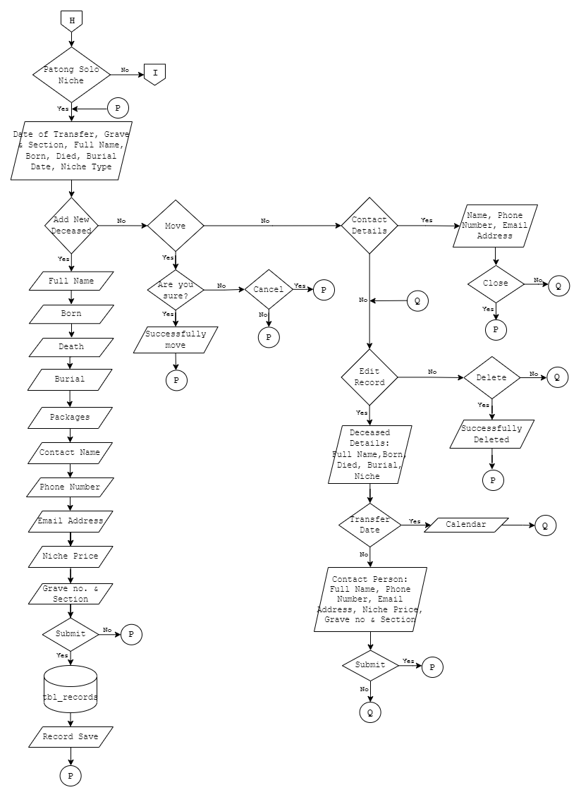

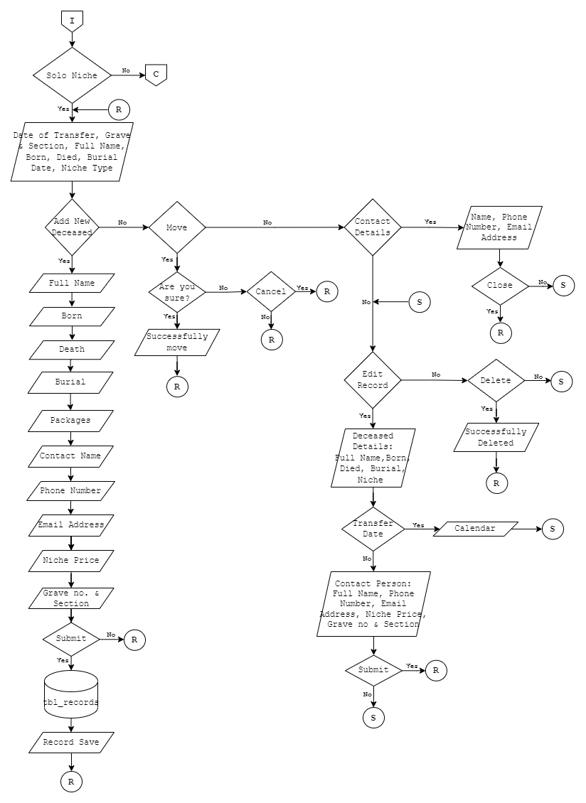

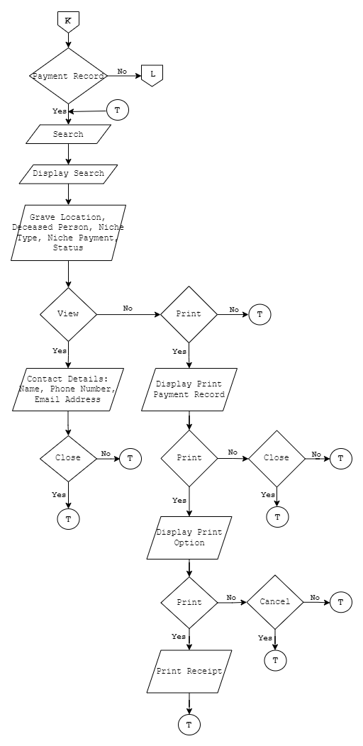

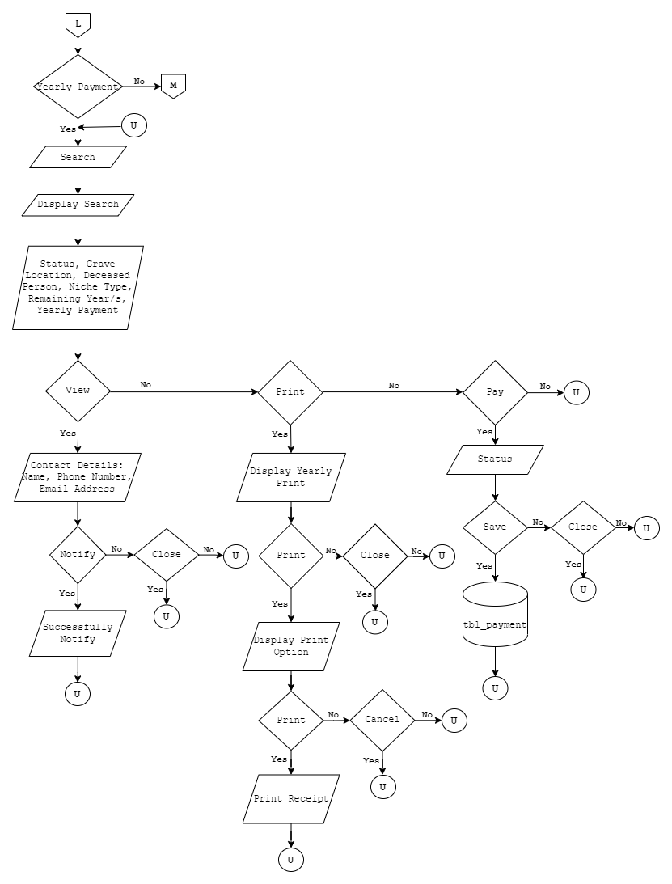

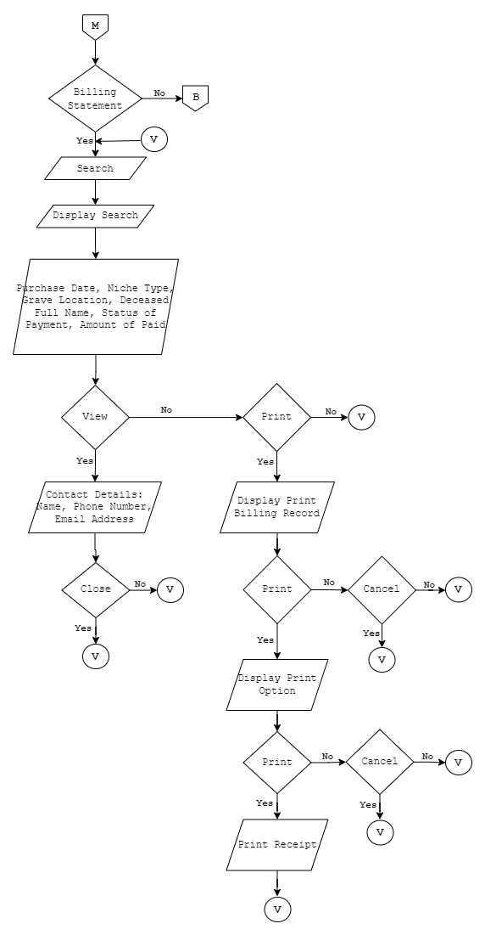

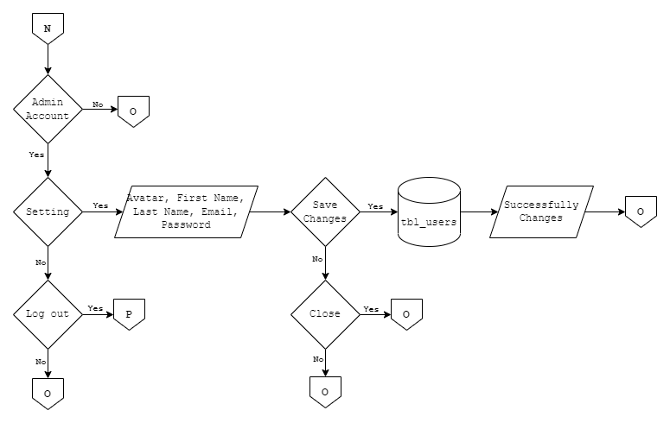

**Figure 9. System Flowchart**

Figure 9 shows the flowchart of the Sts. Peter and Paul Roman Catholic Cemetery Management System. It shows the picture of separate steps of a process in sequential order. Flowchart is a common process analysis tool.

**Software Requirements**

The following are the software requirements for the development and implementation of the web app, Saints Peter & Paul Roman Catholic Cemetery Management System:

* Windows 7 operating system and up
* XAMPP
* Google Chrome as the browser for better compatibility
* Bootstrap

**Hardware and Other Required Devices**

The following are the minimum hardware requirements of the system for it to be functional:

* **Processor:** Intel ® Core ™ i3-4030U CPU @ 1.9GHz
* **RAM:** 1.00 GB
* **Graphics:** Intel ® HD Graphics Control Panel
* **Peripheral:** Mouse, Keyboard/ Touchpad, and printer
* **System Type:** 64-bit operating system, x64-based processor

**Programming Environment**

The system’s interface that is visible to the user is developed using scripting languages such as HTML, CSS, JavaScript, Bootstrap, and jQuery Framework. In terms of back-end programming language, the developer used PHP: Hypertext Pre-processor (PHP) which is the server-side language.

**Test Plan**

To test the system, the researcher of this study will be asking for the validation of the functionality of the system. The measuring tool that will be used in testing is the ISO/IEC 25010 Software Quality Model.

# **CHAPTER IV**

**PRESENTATION, ANALYSIS, AND INTERPRETATION OF RESULTS**

After the evaluation of experts and respondents, the following are generated:

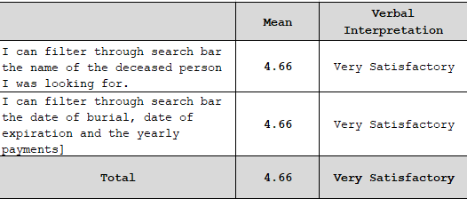

**Table 1. In terms of filters data to the Sts. Peter and Paul Roman Catholic Cemetery Management System**

Table 1 shows the result of the user’s feedback in using the Sts. Peter and Paul Roman Catholic Cemetery Management System in terms of filters data to the Cemetery Management System. The table above shows a mean value of 4.66 which is interpreted as Very Satisfactory.

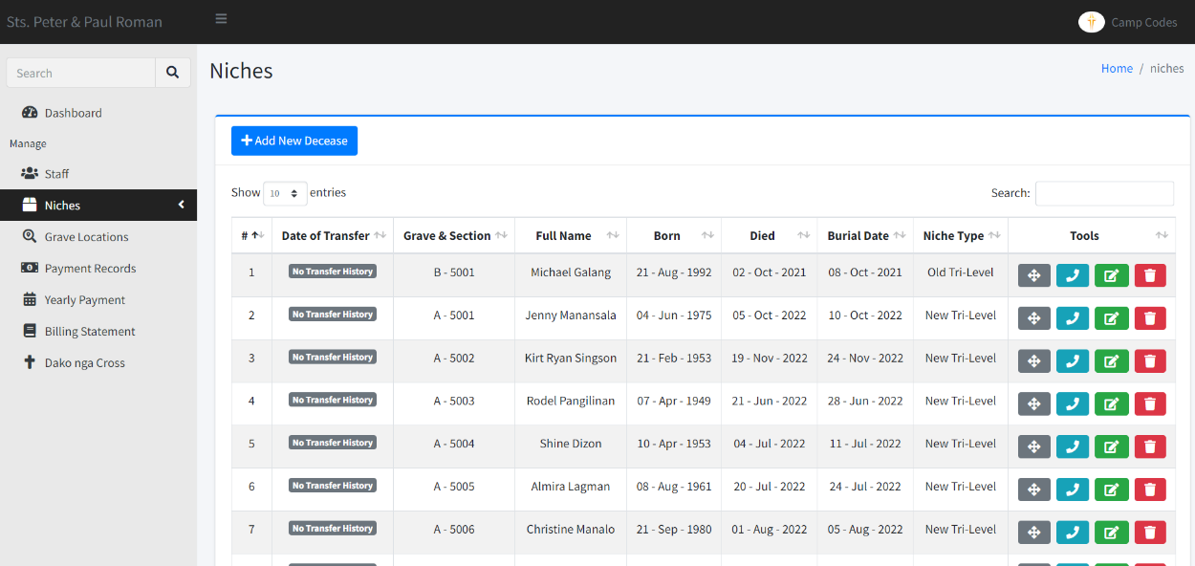

**Figure 10. Filters data to the Cemetery Management System**

Figure 10 shows a part of the Cemetery Management System where administrator can filter data of the deceased persons, Year of Born, Burial, and Death. This functionality of the web application can help administrator to search for a specific record and will help the administrator to save time.

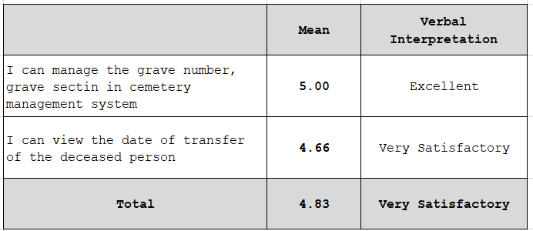

**Table 2. In terms of managing deceased data**

Table 2 shows the administrator can manage the grave number, grave section, in Cemetery Management System. Although it can view the date of transfer of the deceased person. The table above shows a mean value of 4.83 which is interpreted as Very Satisfactory.

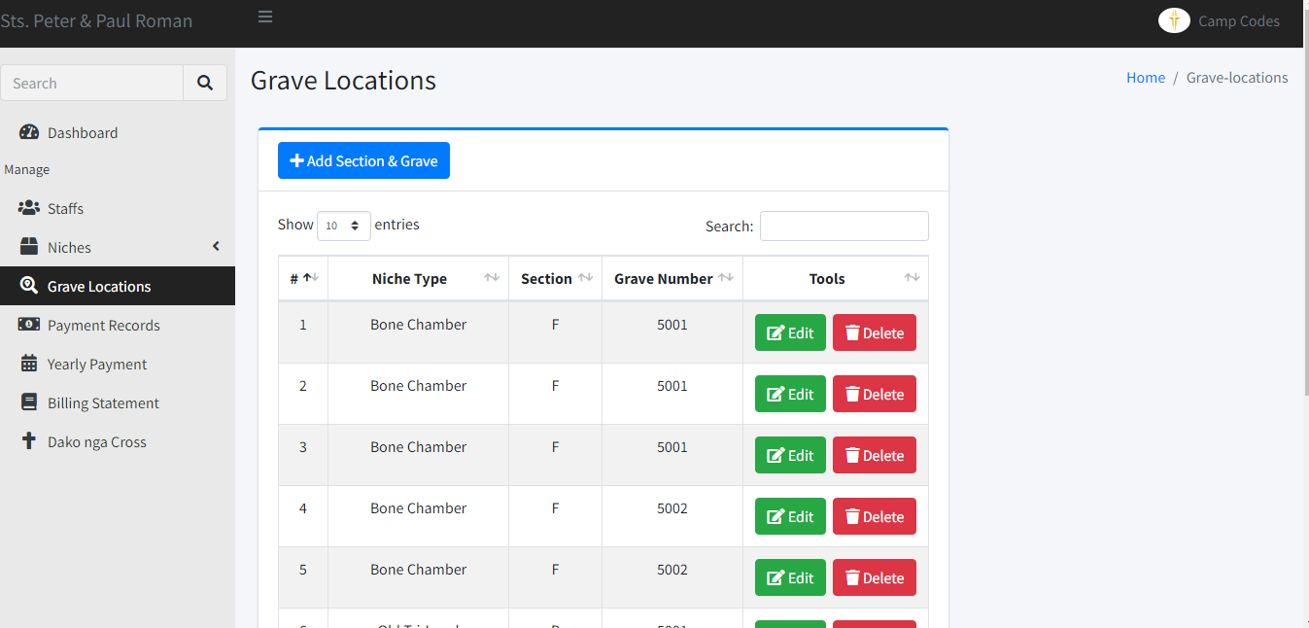

**Figure 11. Admin managing deceased data**

Figure 11 above shows a part of the Sts. Peter and Paul Roman Catholic Cemetery Management System where the admin can add grave number and sections to the system. The admin can edit and delete the location of the grave and section in the Cemetery Management System.

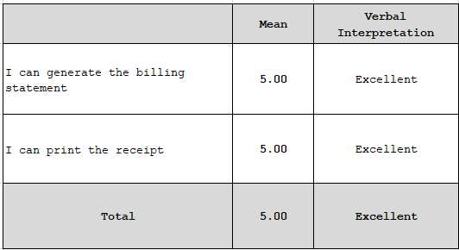

**Table 3. In terms of Generating and Print deceased Data**

Table 3 shows the result of the user's feedback in terms of generating a billing statement and printing the receipt of the system. The table above shows a mean value of 5.00 which is interpreted as Excellent.

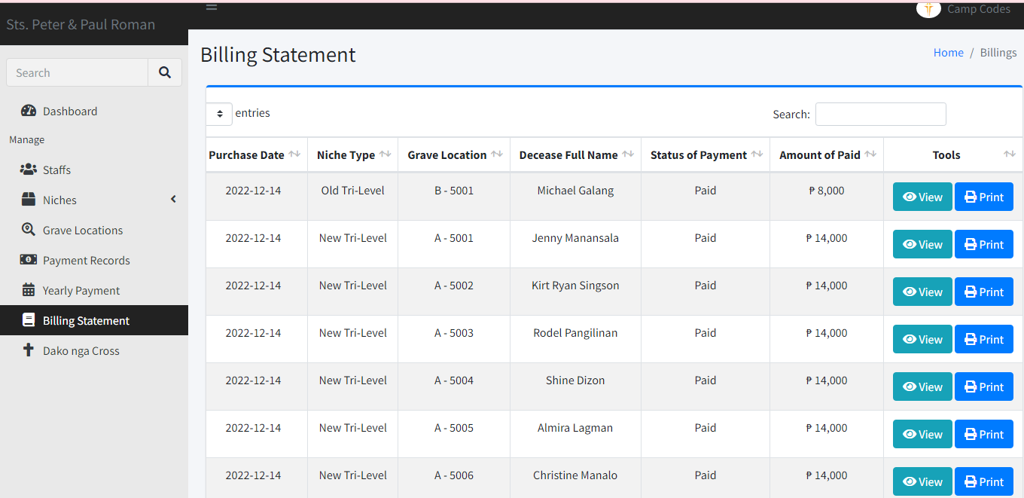

**Figure 12. Generate and Print deceased Data**

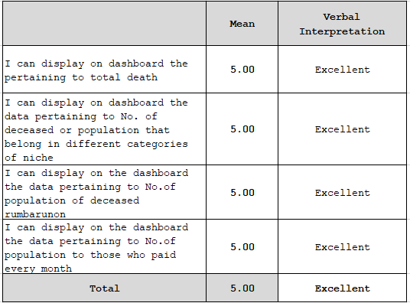Figure 12 above shows a part of the Sts. Peter and Paul Roman Catholic Cemetery Management System where the admin can generate the billing statement, and can print the receipt. It has a search bar on the right side where the admin can summarize the data depending on what is needed like a specific record of the deceased person.

**Table 4. In terms of showing the Descriptive Analysis of Data through the dashboard of the system**

Table 4 shows the result of the user’s feedback in using the Sts. Peter and Paul Roman Catholic Cemetery Management System in terms of the system is accessible online. Moreover, the users give their feedback also in terms of their comfortability in using the Cemetery Management System. The table above shows a mean value of 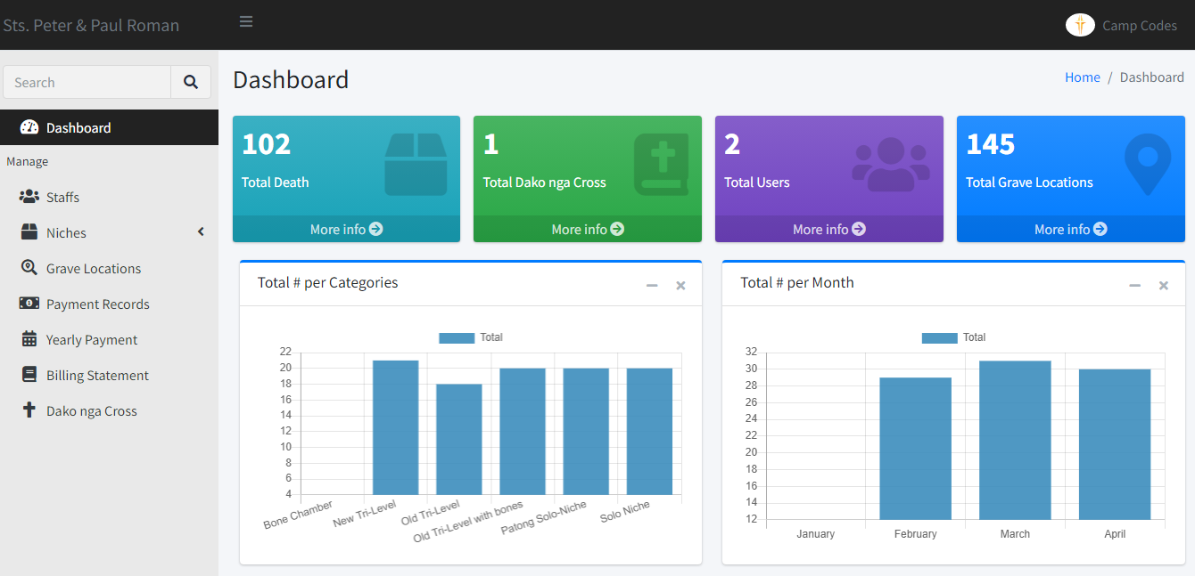5.00 which is interpreted as Excellent.

**Figure 13. In terms of Showing the Descriptive Analysis of Data through the dashboard of the system**

Figure 13 above shows a part of the Sts. Peter and Paul Roman Catholic Cemetery Management System where the admin can display on the dashboard the data pertaining to total death, No. of deceased or population that belong in different categories of niche, No. of the population of deceased *“rumbarunon”* and No. of population to those who paid every month.

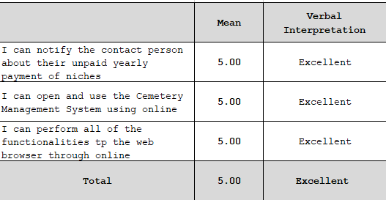

**Table 5. Payment Email Notification**

Table 5 shows the result of the user’s feedback in using the Sts. Peter and Paul Cemetery Management System in terms of the system is accessible online. Moreover, the user can notify the contact person about their unpaid yearly payment of niches and the users give their feedback also in terms of performing all the functionalities of the system. The table above shows a mean value of 5.00 which is interpreted as Excellent.

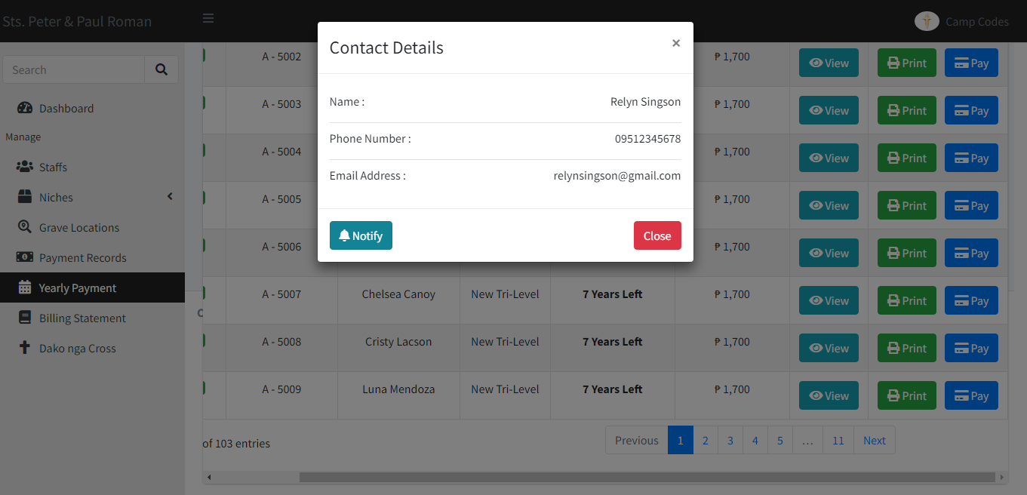

**Figure 14. Payment Email Notification**

The Figure 15 above shows a part of the Sts. Peter and Paul Roman Catholic Cemetery Management System where the admin can notify the contact person of the deceased through Email for their unpaid bills.

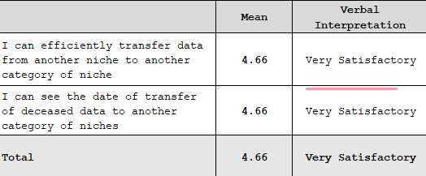

**Table 6. In terms of other functionalities of the system**

Table 6 shows the result of the other functionalities of the system in terms of transferring data of the deceased from another category of niche and showing the date of transfer of data. The table above shows a mean value of 4.66 which is interpreted as Very Satisfactory.

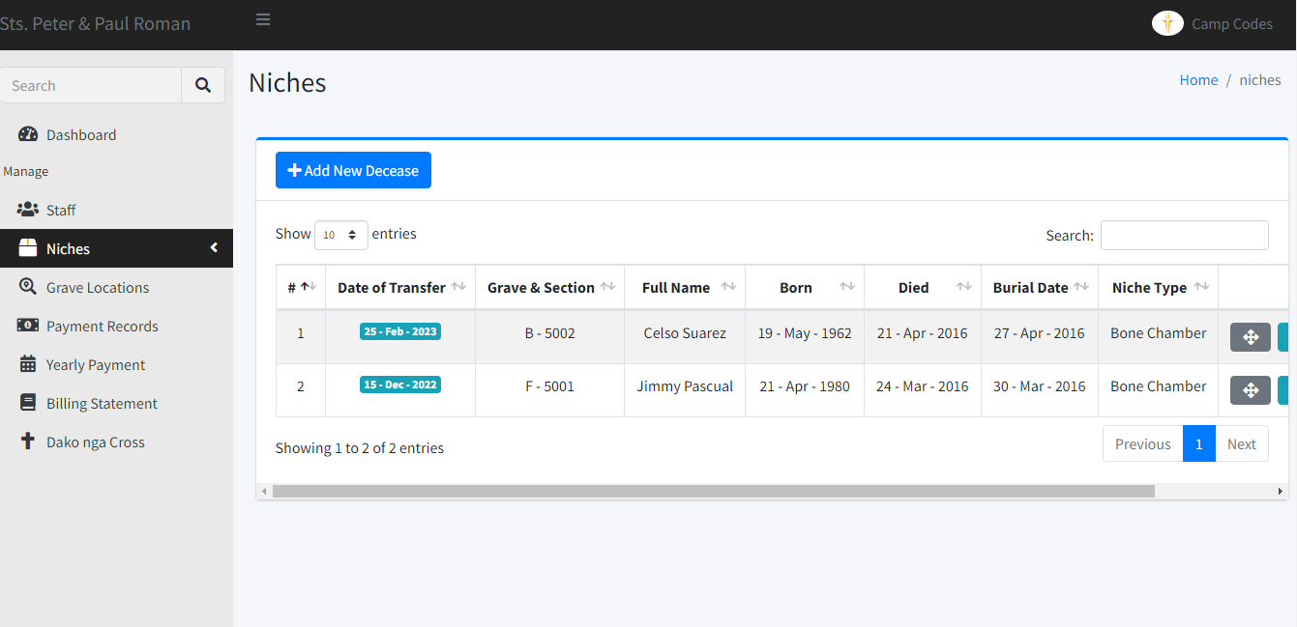

**Figure 15. Transferring Data of the deceased**

Figure 16 above shows a part of the Sts. Peter and Paul Roman Catholic Cemetery Management System where the admin can transfer the deceased data into another category of niche and can see the date of transfer.

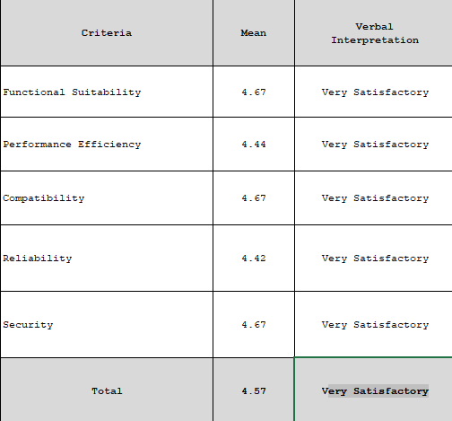

**Table 7. In terms of the characteristics set in ISO 25010 Software Quality Model**

The table 7 above shows the result of the IT Experts’ feedback in determining the quality of the Online Attendance Monitoring System on the characteristics set in the ISO 25010 Software Quality Model.

In terms of Functional Suitability, it was rated with a mean value of 4.67, which is interpreted as Very Satisfactory. With regards to Performance Efficiency, it was rated with a mean value of 4.44, which is interpreted as Very Satisfactory. Compatibility, it was rated with a mean value of 4.67.

Concerning Reliability, it was rated with a mean value of 4.42, which is interpreted as Very Satisfactory. As to Security, it was rated with a mean value of 4.67, which is interpreted as Very Satisfactory.

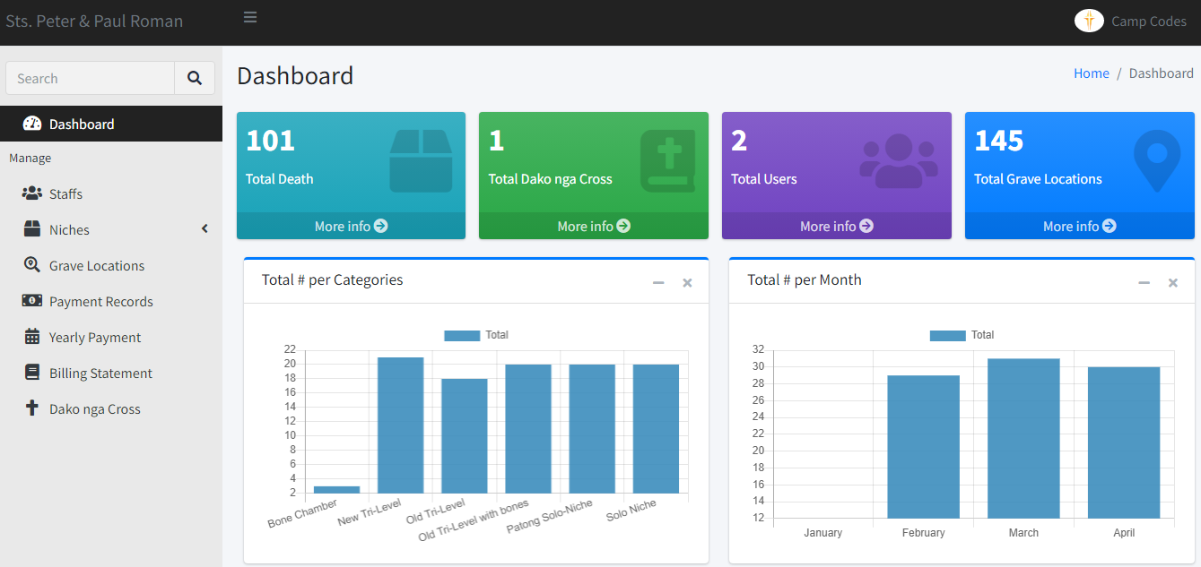

**Figure 16. Sts. Peter and Paul Roman Catholic Cemetery Management System Main Page**

Figure 16 shows the dashboard of the Sts. Peter and Paul Roman Catholic Cemetery Management System where the number of total death, total *Dako nga Cross*, users, and grave locations is all visible to the homepage part of the system. It helps the admin to identify the number of total death, total *Dako nga Cross*, users and grave locations registered to the web application.

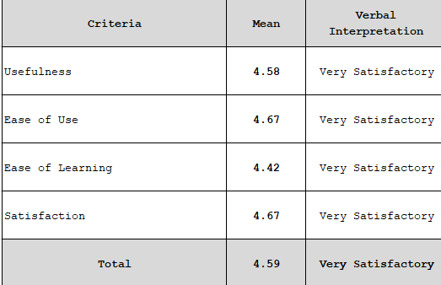

**Table 8. In terms of usefulness, satisfaction, and ease** **of use, and learning**

Table 8 shows the result of the users’ feedback in determining the usability of the Sts. Peter and Paul Roman Catholic Cemetery Management System based on usefulness, satisfaction, and ease of use and learning.

In terms of Usefulness, it was rated with a mean value of 4.58, which is interpreted as Very Satisfactory. With regards to Ease of Use, it was rated with a mean value of 4.67, which is interpreted as Very Satisfactory. As to Ease of Learning, it was rated with a mean value of 4.42, which is interpreted as Very Satisfactory. Lastly, with regards to Satisfaction, it was rated with a mean value of 4.67, which is interpreted as Very Satisfactory.

# **CHAPTER V**

**SUMMARY, CONCLUSION AND RECOMMENDATIONS**

**Summary of Findings**

Based on a detailed presentation, discussions, interpretation, and analysis of research findings, the following summary is now presented:

1. In terms of filters data to the Sts. Peter anad Paul Roman Catholic Cemetery Management System, it was rated with a mean value of 4.66 which has a verbal interpretation of Very Satisfactory.
2. In terms of admin managing deceased data they can manage the grave number, grave section in Cemetery Management System and can view the date of transfer of the deceased person. It was rated with a mean value of 4.83 which has a verbal interpretation of Very Satisfactory.
3. In terms of generate and print deceased data in Cemetery Management System they can generate the billing statement and can print the receipt, it was rated with a mean value of 5.00 which has a verbal interpretation of Excellent.
4. In terms of showing the descriptive Analysis of the data through the dashboard of the system pertaining to total death, No. of deceased or population that belong in different categories of niche, No. of population of deceased rumbarunon and No. of population to those who paid every month, it was rated with a mean value of 5.00 which has a verbal interpretation of Excellent.
5. In terms of Payment Email Notification that can notify the contact person about their unpaid yealy payment of niches, Cemetery Management System accessible online and can perform all the functionalities , it was rated with a mean value of 5.00, which is interpreted as Excellent.
6. In terms of other functionalities of Cemetery Management System that can efficiently transfer data from another niche to another category of niche ad can see the date of transfer of deceased data to another category of niche, it was rated with a mean value of 4.66, which is interpreted as Very Satisfactory.
7. In terms of determining the quality of the Sts. Peter and Paul Roman Catholic Cemetery Management System with machine learning Integration based on characteristics set in ISO 25010 Software Quality Model, it was rated with a mean value of 4.56, which is interpreted as Very Satisfactory.
8. In terms of determining the usability of the Sts. Peter and Paul Roman Catholic Cemetery Management System based on usefulness, satisfaction, and ease of use and learning, it was rated with a mean value of 4.59, which is interpreted as Very Satisfactory.

**Conclusion**

The web application, Sts. Peter and Paul Roman Catholic Cemetery Management System provides convenience in order for the parochial administrator and the Contact person. In addition, the researcher concludes that, based on the evaluation of the respondents that the web app, Cemetery Management System is user-friendly, right color scheme, whitespace, simple navigation, and it is easy now on monitor the death data as it safe and easy to access.

The Cemetery Management System is great of help in terms of managing deceased data, can view the date of transfer of the deceased person. The parochial admin can can easily view the descriptive Analysis of the Data through dashboard. Moreover, The administrator can notify the contact person about their unpaid bills. Therefore, the Sts. Peter and Paul Roman Catholic Cemetery Management System was a useful tool in managing records and can perform all the functionalities to the web browser online.

**Recommendation**

Based on the findings and conclusion drawn, the following recommendations are put forward:

1. The Administrator and Instructors of the Madridejos Community College may consider implementing this system to:
   1. Filters deceased data, date of burial, date of expiration and also the yearly payments of the contact person so that it would be easy to find the record that they are looking for.
   2. Adding parochial admin account for the new user of the Web app, Sts. Peter and Paul Roman Catholic Cemetery Management System so that they would be able to log in and access the operation and death data summary of the system.
   3. Adding the grave number, grave section first before adding the deceased person and contact person, it needs the death information and description.
   4. Generating the billing statements requires the date of paying, name of contact person, contact number and the address. It will show the death data summary based of what is being search and it can be printed.
2. Viewing the dashboard in the system pertaining to the total death, No. of deceased or population that belong in different categories of niche, No. of population of deceased rumbarunon, and lastly No. of population to those who paid every month. Moreover, parochial admin should know what happened in the dashboard of the system.
3. It is recommended to notify the contact person about their unpaid yearly payments of niches and be always reminded about their payments to avoid their dead love ones being transferred to “Dako na Cross”.
4. Further, it is also recommended that a similar study may be conducted to improve the Sts. Peter and Paul Roman Catholic Cemetery Management System.

**REFERENCES**

Abdullah, S., Hussain, N. H. M., Talib, N., Hashim, I. C., Hashim, H., & Osoman, M. A. (2022). Development of Muslim Graveyard Management System (MGMS) Using Geospatial Technology Applications. International Journal of Academic Research in Progressive Education and Development, 11(4), pp. 191–199. DOI:10.6007/IJARPED/v11-i4/15035

Chibuye, B., Phiri, J. (2022). An Assessment for Record Keeping and Cemetery Management: A Case of Lusaka City Council, Zambia Based on Technology Acceptance Model (TAM). Open Journal of Business and Management, 10, 577-590.doi.org/10.4236/ojbm.2022.102032

Demir, N., Yogeswaran, N. (2018). Semi－Automated Cemetery using smartphones. The International archives of the Photogrammetry, Remote Sensing and Spatial Information Sciences, Vol XLII－5-59.DOI:10.5194/isprs-archives-XLII-5-59-2018

Komalasari, R. (2020). The Waqf Cemetery Information System. IOP Conf. Ser.: Mater. Sci. Eng. 879 012035.DOI:10.1088/1757-899X/879/1/012035

Muhammad, I. (2015). The art of Data Analysis. Journal of Allied Health Sciences Pakistan. 1. pp.98-104.

Sarı, S., Türk, T.Phd, Esra, M., Atilla, A., Veysi, O.G., Elhami, I., Gokhan, P., Adem, S. (2017). Cemetery Information System. Conference: UCTEA International Geographical Information Systems Congress2017. <https://www.researchgate.net/publication/322295339_Cemetery_Information_System_A_Case_Study_in_Sivas_City>

Schmidt, M., Yuan, F., Jang, W. (2020). Cemetery Mapping and Digital Data Analysis: A Case Study in Minnesota, USA. Journal of Geography and Geology; Vol. 12, No. 2. doi:10.5539/jgg. v12n2p4

Sien, T.E., Ramachandrian, C.R. (2018). E-Cemetery Portal: A Tool for Digitizing the Cemetery Culture in Malaysia. Journal of Applied Technology and Innovation (e-ISSN: 2600-7304) vol. 2, no. 1.

Sultana, M., Khandaker, N., Anannya, T.T., Islam, M.N (2021). Requirements Elicitation and Development of a Graveyard Management System in the Context of Bangladesh, International Conference on Science & Contemporary Technologies (ICSCT), Dhaka, Bangladesh, 2021, pp. 1-6, doi: 10.1109/ICSCT53883.2021.9642654

Welim, Y.Y, Fauzi, A. (2017). Cemetery Service Information System in the General Cemetery. International Journal of Pure and Applied Mathematics Volume 117 No. 15, pp. 963-971

**Internet Sources**

ADAMS (2021). CONTEXT FLOW DIAGRAM. Retrieved on November 11, 2022 from <https://www.modernanalyst.com/Careers/InterviewQuestions/tabid/128/ID/1433/What-is-a-Context-Diagram-and-what-are-the-benefits-of-creating-one.aspx>

Axiom (2022). Retrieved on October 25, 2022, from <https://axiom-cms.com/solutions/experience/>

Biscobing J. (2021). Entity-Relationship Diagram. Retrieved on November 12, 2022 from <https://www.techtarget.com/searchdatamanagement/definition/entity-relationship-diagram-ERD>

Cemsites (2022). Retrieved on October 23, 2022, from <https://cemsites.com/cemeteries-by-type/catholic-cemeteries/>

Cemetery Find (2020). Retrieved on October 25, 2022, from https://www.bosscan.com/cemfind.html

Cemify (2020). Retrieved on October 26, 2022, from https://www.cemify.com/features

Everark (2022). Retrieved on October 25, 2022, from https://www.capterra.com/p/239533/EverArk/

Gamas, Galvez, Tupaz (2020). Cemetery Management System for Manila Southx. Retrieved on September 23, 2022, from https://www.coursehero.com/file/69087621/

Geocem (2020). Retrieved on October 26, 2022, from https://cemeterysoftware.co.uk/

Grave Discover (2022). Retrieved on October 27, 2022 from <https://www.beavercreekohio.gov/752/Grave-Discover>

Kelly K. (2022). What is Data Analysis: Methods, Process and Types Explained. Retrieved on March 8,2023, from <https://www.simplilearn.com/data-analysis> method-process-types-article#what_is_data_analysis

LORENZO (2015). Online Cemetery Management of Heavenly Peace Memorial Garden. Retrieved on October 8, 2022, from https://www.academia.edu/20126834/Final_1_to_3

LUCIDCHART (2021). Entity - Relationship Diagram. Retrieved on November 15, 2022, from https://www.lucidchart.com/pages/er-diagrams

MEARDON (2021). What are Gantt Charts. Retrieved on November 11, 2021, from <https://www.atlassian.com/agile/project> management/gantt-chart

Newcom. CMS (2013). Retrieved on October 25, 2022, from https://cemetery.newcomtech.com/

NOLLE (2021). Physical and Logical DFDs. Retrieved on November 12, 2021, from <https://searchdatamanagement.techtarget.com/definit> on/data-flow-diagram-DFD

Online Reservation of Cemetery with Map Navigation (2020). Retrieved on March 9, 2023, from <https://www.inettutor.com/source-code/online> reservation-of-cemetery-with-map-navigation/

PlotBox (2022). Retrieved on October 26, 2022, from https://www.plotbox.io/records-management

Redhat (2020). Application Architecture. Retrieved on November 14, 2022, from <https://www.redhat.com/en/topics/cloud-native> apps/what-is-an-application-architecture

Scribe (2020). Retrieved on October 27, 2022, from https://www.scribeaccounts.com/cemetery

Smartdraw (2022). Use Case Diagram. Retrieved on November 15, 2022, from https://www.smartdraw.com/use-case-diagram/

William M.K. (2022). Descriptive Statistics. Retrieved on March 6, 2023, from https://conjointly.com/kb/descriptive-statistics/

# **APPENDIX A**

## EXPERT EVALUATION USING ISO/IEC 25010

## SOFTWARE QUALITY MODEL

**Name: _____________________ Company: _________________**

**Position: ________________ Specialization: ______________**

**Direction:** Listed below are the characteristics of a Software or Product as based on **ISO/IEC 25010 Software Quality Model**.

Each of the items is provided with five options. Please read each item carefully and **check (/)** the box that closely represents your choice.

Rating Scale:

[5] Very Good [4] Good [3] Average [2] Fair [1] Poor

How would you rate the developed system, **“STS. PETER AND PAUL ROMAN CATHOLIC CEMETERY MANAGEMENT SYSTEM”** in terms of the following software criteria:

|  |  |
| --- | --- |
| **Functional Suitability**  the degree to which a product or system provides functions that meet stated and implied needs when used under specified conditions |  |
| * **Functional completeness.** Degree to which the set of functions covers all the specified tasks and user objectives. | [1] [2] [3] [4] [5] |
| * **Functional correctness.** Degree to which a product or system provides the correct results with the needed degree of precision. | [1] [2] [3] [4] [5] |
| * **Functional appropriateness.** Degree to which the functions facilitate the accomplishment of specified tasks and objectives. | [1] [2] [3] [4] [5] |
| **Performance efficiency**  the performance relative to the amount of resources used under stated conditions |  |
| * **Time behaviour.** Degree to which the response and processing times and throughput rates of a product or system, when performing its functions, meet requirements. | [1] [2] [3] [4] [5] |
| * **Resource utilization.** Degree to which the amounts and types of resources used by a product or system, when performing its functions, meet requirements. | [1] [2] [3] [4] [5] |
| * **Capacity.** Degree to which the maximum limits of a product or system parameter meet requirements. | [1] [2] [3] [4] [5] |
| **Compatibility**  Degree to which a product, system or component can exchange information with other products, systems or components, and/or perform its required functions, while sharing the same hardware or software environment. |  |
| * **Co-existence.** Degree to which a product can perform its required functions efficiently while sharing a common environment and resources with other products, without detrimental impact on any other product. | [1] [2] [3] [4] [5] |
| * **Interoperability.** Degree to which two or more systems, products or components can exchange information and use the information that has been exchanged. | [1] [2] [3] [4] [5] |
| * **Appropriateness recognisability.** Degree to which users can recognize whether a product or system is appropriate for their needs. | [1] [2] [3] [4] [5] |
| * **Learnability.** degree to which a product or system can be used by specified users to achieve specified goals of learning to use the product or system with effectiveness, efficiency, freedom from risk and satisfaction in a specified context of use. | [1] [2] [3] [4] [5] |
| * **Operability.** Degree to which a product or system has attributes that make it easy to operate and control. | [1] [2] [3] [4] [5] |
| * **User error protection.** Degree to which a system protects users against making errors. | [1] [2] [3] [4] [5] |
| * **User interface aesthetics.** Degree to which a user interface enables pleasing and satisfying interaction for the user. | [1] [2] [3] [4] [5] |
| * **Accessibility.** Degree to which a product or system can be used by people with the widest range of characteristics and capabilities to achieve a specified goal in a specified context of use. | [1] [2] [3] [4] [5] |
| **Reliability**  Degree to which a system, product or component performs specified functions under specified conditions for a specified period of time |  |
| * **Maturity.** Degree to which a system, product or component meets needs for reliability under normal operation. | [1] [2] [3] [4] [5] |
| * **Availability**. Degree to which a system, product or component is operational and accessible when required for use. | [1] [2] [3] [4] [5] |
| * **Fault tolerance.** Degree to which a system, product or component operates as intended despite the presence of hardware or software faults. | [1] [2] [3] [4] [5] |
| * **Recoverability.** Degree to which, in the event of an interruption or a failure, a product or system can recover the data directly affected and re-establish the desired state of the system. | [1] [2] [3] [4] [5] |
| **Security**  Degree to which a product or system protects information and data so that persons or other products or systems have the degree of data access appropriate to their types and levels of authorization. |  |
| * **Confidentiality.** Degree to which a product or system ensures that data are accessible only to those authorized to have access. | [1] [2] [3] [4] [5] |
| * **Integrity.** Degree to which a system, product or component prevents unauthorized access to, or modification of, computer programs or data. | [1] [2] [3] [4] [5] |
| * **Non-repudiation.** Degree to which actions or events can be proven to have taken place, so that the events or actions cannot be repudiated later. | [1] [2] [3] [4] [5] |

# **APPENDIX B**

## RESULTS OF EXPERT EVALUATION USING ISO/IEC 25010

## SOFTWARE QUALITY MODEL



# **APPENDIX C**

## EVALUATION INSTRUMENT

**USE Questionnaire: Usefulness, Satisfaction, and Ease of use**

Based on: Lund, A.M. (2001) Measuring Usability with the USE Questionnaire. STC Usability SIG Newsletter, 8:2.

**Name of System:** **Sts. Peter and Paul Roman Catholic Cemetery Management System**

Instruction: Please rate the system on how strongly you agree or disagree with each of the following statements by placing a check mark in the appropriate box.

**Legend:**

1 – Strongly Disagree 2 – Disagree

3 - Neither agree nor disagree 4 – Agree

5 – Strongly Agree

|  |  |  |  |  |  |
| --- | --- | --- | --- | --- | --- |
| **Usefulness** | **1** | **2** | **3** | **4** | **5** |
| It helps me be more effective. |  |  |  |  |  |
| It helps me be more productive. |  |  |  |  |  |
| It is useful. |  |  |  |  |  |
| It gives me more control over the activities in my life. |  |  |  |  |  |
| It makes the things I want to accomplish easier to get done. |  |  |  |  |  |
| It saves me time when I use it. |  |  |  |  |  |
| It meets my needs. |  |  |  |  |  |
| It does everything I would expect it to do. |  |  |  |  |  |

|  |  |  |  |  |  |
| --- | --- | --- | --- | --- | --- |
| **Ease of Use** | **1** | **2** | **3** | **4** | **5** |
| It is easy to use. |  |  |  |  |  |
| It is simple to use. |  |  |  |  |  |
| It is user friendly. |  |  |  |  |  |
| It requires the fewest steps possible to accomplish what I want to do with it. |  |  |  |  |  |
| It is flexible. |  |  |  |  |  |
| Using it is effortless. |  |  |  |  |  |
| I can use it without written instructions. |  |  |  |  |  |
| I don't notice any inconsistencies as I use it. |  |  |  |  |  |
| Both occasional and regular users would like it. |  |  |  |  |  |
| I can recover from mistakes quickly and easily. |  |  |  |  |  |
| I can use it successfully every time. |  |  |  |  |  |

|  |  |  |  |  |  |
| --- | --- | --- | --- | --- | --- |
| **Ease of Learning** | **1** | **2** | **3** | **4** | **5** |
| I learned to use it quickly. |  |  |  |  |  |
| I easily remember how to use it. |  |  |  |  |  |
| It is easy to learn to use it. |  |  |  |  |  |
| I quickly became skillful with it. |  |  |  |  |  |

|  |  |  |  |  |  |
| --- | --- | --- | --- | --- | --- |
| **Satisfaction** | **1** | **2** | **3** | **4** | **5** |
| I am satisfied with it. |  |  |  |  |  |
| I would recommend it to a friend. |  |  |  |  |  |
| It is fun to use. |  |  |  |  |  |
| It works the way I want it to work. |  |  |  |  |  |
| It is wonderful. |  |  |  |  |  |
| I feel I need to have it. |  |  |  |  |  |
| It is pleasant to use. |  |  |  |  |  |

List the most **negative** aspect(s):

_______________________________________________________________________________________________________________________________________________________________________________________________________________________________________________________________

List the most **positive** aspect(s):

_______________________________________________________________________________________________________________________________________________________________________________________________________________________________________________________________

# **APPENDIX D**

## EVALUATION INSTRUMENT

**Result of USE Questionnaire: Usefulness, Satisfaction, and Ease of use of Online Attendance Monitoring System**

Based on: Lund, A.M. (2001) Measuring Usability with the USE Questionnaire. STC Usability SIG Newsletter, 8:2.



# **APPENDIX E**

**PLAGIARISM CHECK RESULT**

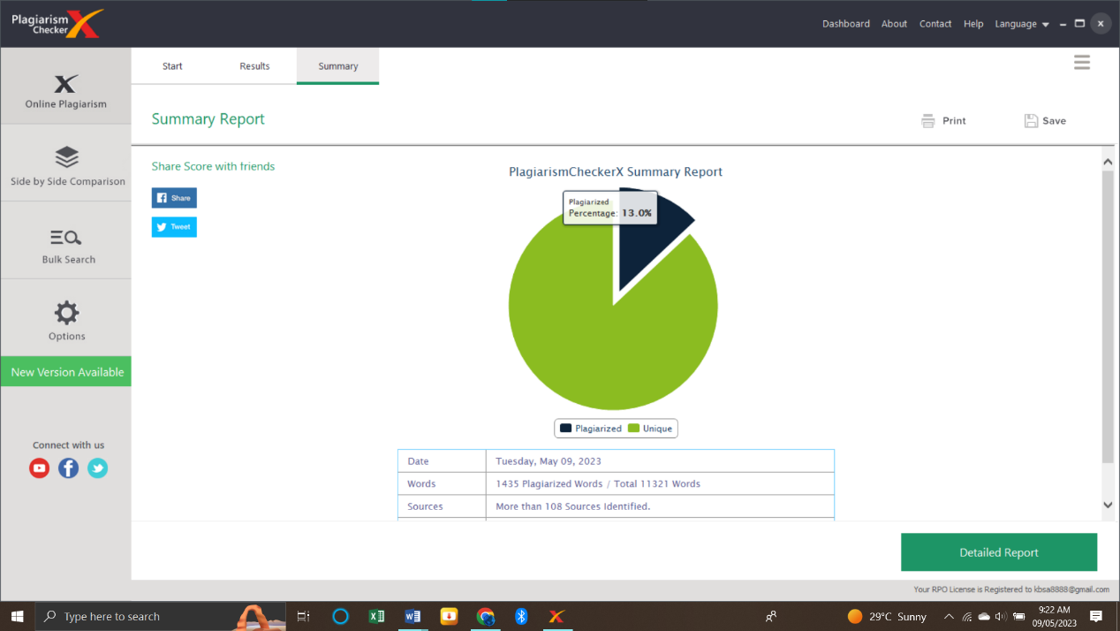

# 

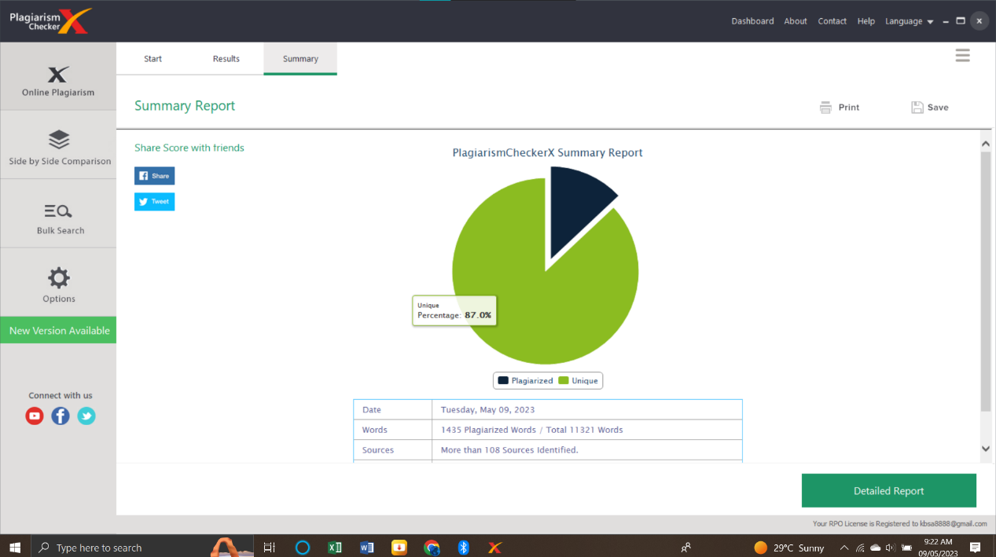

# **APPENDIX F**

## 

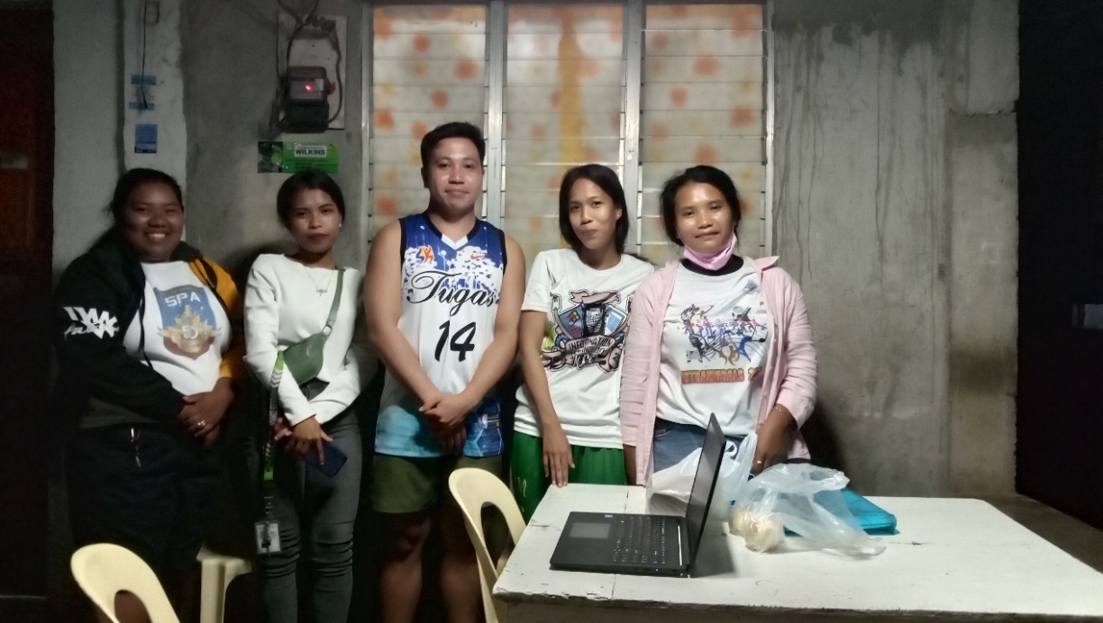**DOCUMENTATIONS**

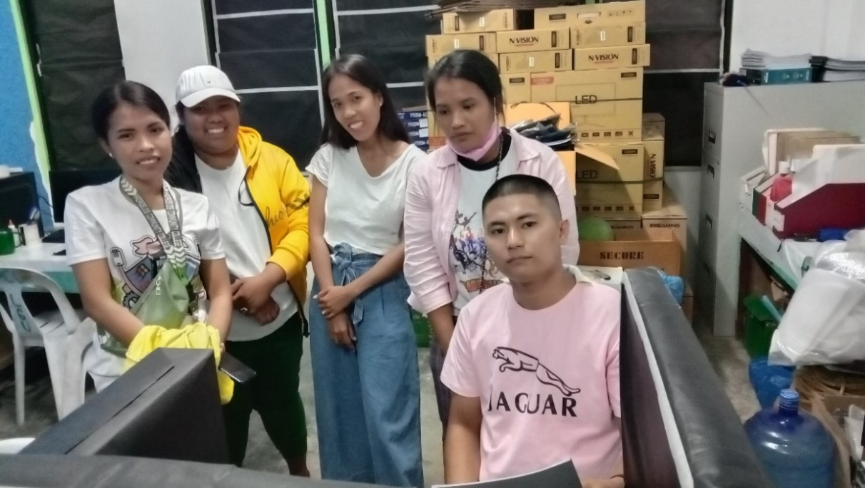This picture was taken at Tugas Madridejos, Cebu with Mr. Juniel Marfa a BSIT Instructor during the IT expert’s survey.

This picture was taken at Madridejos Community College with Mr. Alvine Billones a BSIT Instructor during the IT expert’s survey.

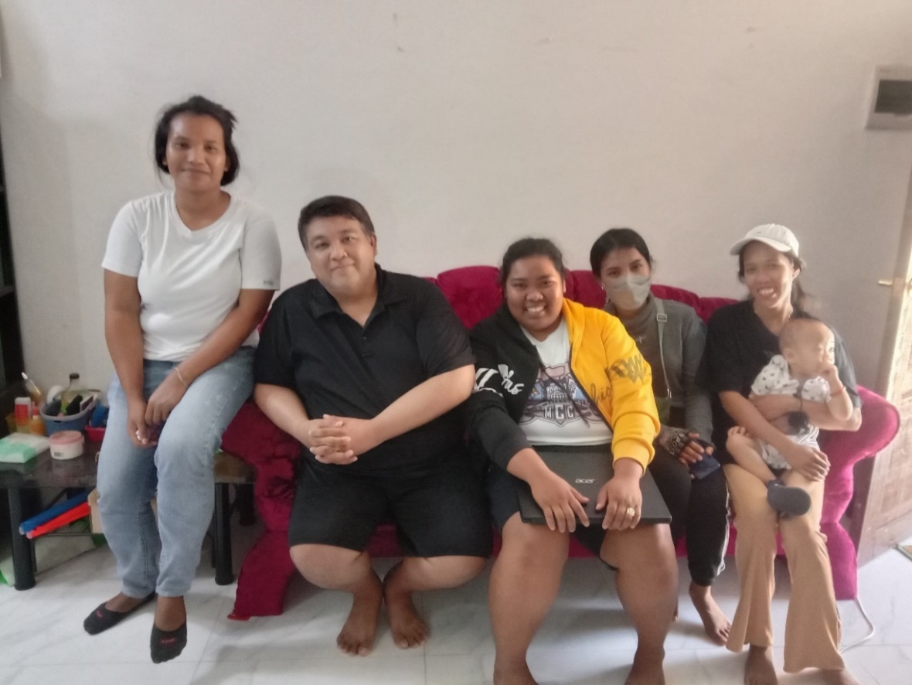

This picture was taken at NHA or housing in Brgy. Kodia with Mr. Ernest Gierran Pestaño an Axoneure A.I Technology Senior A.I programmer during the IT expert’s survey.

# **CURRICULUM VITAE**



**CRISTEL JOY C. PATUBO**

Kabac, Bantayan, Cebu, Philippines

Cellphone Number: +639956708057

[cristeljoycordova@gamil.com](mailto:cristeljoycordova@gamil.com)

**PERSONAL INFORMATION:**

Age : 21 years old

Date of Birth : October 04, 2001

Place of Birth : Lapu-lapu, Cebu, City

Sex : Female

Civil Status : Single

Religion : Roman Catholic

Height : 5’2”

Weight : 231 Lbs.

**EDUCATIONAL BACKGROUND:**

Tertiary Education:

Madridejos Community College

Bunakan, Madridejos, Cebu

S.Y. 2022-2023

Secondary Education:

Madridejos National High School

Poblacion, Madridejos, Cebu

S.Y. 2018-2019

Elementary Education:

Kampingganon Elementary School

Kampingganon, Bantayan, Cebu

S.Y. 2012-2013



**SHEENAROSE A. SOLIS**

Pili, Madridejos, Cebu, Philippines

Cellphone Number: +639672191404

[solissheenarose@gmail.com](mailto:solissheenarose@gmail.com)

**PERSONAL INFORMATION:**

Age : 24 years old

Date of Birth : July 11, 1998

Place of Birth : Pili, Madridejos, Cebu

Sex : Female

Civil Status : Single

Religion : Roman Catholic

Height : 5’3”

Weight : 43kg.

**EDUCATIONAL BACKGROUND:**

Tertiary Education:

Madridejos Community College

Bunakan, Madridejos, Cebu

S.Y. 2022-2023

Secondary Education:

Madridejos National High School

Poblacion, Madridejos, Cebu

S.Y. 2013-2014

Elementary Education:

San Agustin Elementary School

San Agustin, Madridejos, Cebu

S.Y. 2010-2011



**RAQUEL O. ALMOCERA**

Mojon, Bantayan, Cebu, Philippines

Cellphone Number: +639467125830

[raquelalmocera815@gmail.com](mailto:raquelalmocera815@gmail.com)

**PERSONAL INFORMATION:**

Age : 25 years old

Date of Birth : August 15, 1997

Place of Birth : Mojon, Bantayan, Cebu

Sex : Female

Civil Status : Single

Religion : Iglesia Filipina Independiente

Height : 4’11”

Weight : 95 Lbs.

**EDUCATIONAL BACKGROUND:**

Tertiary Education:

Madridejos Community College

Bunakan, Madridejos, Cebu

S.Y. 2022-2023

Secondary Education:

Santa Fe National High School

Poblacion, Santa Fe, Cebu

S.Y. 2013-2014

Elementary Education:

Maricaban Elementary School

Maricaban, Santa Fe, Cebu

S.Y. 2009-2010



**ROSEMARIE O. ALMOCERA**

Mojon, Bantayan, Cebu, Philippines

Cellphone Number: +639631533270

[rosemariealmocera@gmail.com](mailto:rosemariealmocera@gmail.com)

**PERSONAL INFORMATION:**

Age : 28 years old

Date of Birth : November 12, 1994

Place of Birth : Mojon, Bantayan, Cebu

Sex : Female

Civil Status : Single

Religion : Roman Catholic

Height : 5’2”

Weight : 65kg.

**EDUCATIONAL BACKGROUND:**

Tertiary Education:

Madridejos Community College

Bunakan, Madridejos, Cebu

S.Y. 2022-2023

Secondary Education:

Pajo National High School

Sangi, Lapu-Lapu , Cebu

S.Y. 2011-2012

Elementary Education:

Maricaban Elementary School

Maricaban, Santa Fe, Cebu

S.Y. 2007-2008